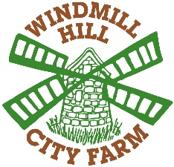
Farm Support Volunteer: Helping others to farm
Role Title Farm Support Volunteer  Commitment (Days and Times)  One of the following sessions:  - Tuesday 13:15 – 15:30  12 weeks minimum commitment  This is an opportunity to learn more about supporting people with mental health problems and learning disabilities and activities that support better mental health and inclusion. You will develop experience of working in a Health and Social Care team in a community organisation. | Main activities/ tasks  - Assist individuals with support needs with day-to-day farm tasks, mucking out for example, and help them feel at ease.  - Develop an understanding of individual needs and monitor these with staff.  - Support the group leader to run the volunteer farming group with ease.
Skills, Experience and Qualities You Need  - Good communication skills.  - Happy to work with animals.  - A friendly, welcoming, and inclusive approach to supporting all people.  - Some experience of working with adults with mental health problems and/or learning disabilities is helpful.  - Ability to work effectively as a member of a team.  - An understanding of confidentiality. | Support and training  - Initial induction  - Regular supervision, support, and training where appropriate to develop your skills in the areas you would like to focus on.  - Volunteer meetings with the opportunity to socialise with fellow volunteers and discuss project development
For more information, contact
Sarah Mountford
Volunteer and Project Coordinator
sarah.mountford@windmillhillcityfarm.org.uk
https://www.windmillhillcityfarm.org.uk/get-involved/volunteering/
0117 947 1194

