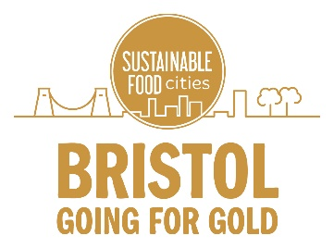

Going for Gold boilerplate text and statement of support

You can use the Going for Gold boilerplate text online or in print to summarise the Going for Gold campaign. Use the statement of support to tell people why your organisation is supporting the Going for Gold bid.

Boilerplate text

Going for Gold is a Bristol-wide bid to be recognised as a Gold Sustainable Food City. Sustainable Food Cities is a national programme that celebrates and supports communities that are making positive changes to their food system. As one of the first three cities to achieve Silver status, Bristol has already shown that it has the motivation to make Good Food part of the city’s identity. Now, individuals, organisations and policy makers are joining together to make big and lasting improvements across six key Food Action Areas. Visit www.goingforgoldbristol.co.uk to find out how you can play a part in this major leap towards making food that is good for people, the planet and the city accessible to everyone.

Statement of Support

We’re joining individuals, organisations and policy makers across Bristol to take action and support Bristol Going for Gold—a citywide effort to change food in our city for good. Our actions will contribute to big and lasting improvements to our city’s food system, and bring about positive changes for Bristol’s communities, environment and workplaces. Collectively, our actions will form the Going for Gold bid, and help Bristol achieve its aspiration of being named a Gold Sustainable Food City by autumn 2020. Anyone can join the bid by visiting www.goingforgoldbristol.co.uk.

