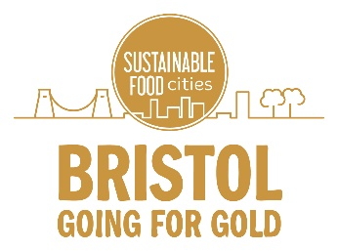

Going for Gold key messages

Use these key messages to communicate in any format to your colleagues, clients and customers, or other stakeholders about the Going for Gold campaign.

Tagline: Bristol is Going for Gold: Take action to change food in Bristol for good.

What is Going for Gold?

Going for Gold is a city-wide effort to make big and lasting improvements to Bristol’s food system and be recognised as a Gold Sustainable Food City by the end of 2020.

The Sustainable Food Cities Network is a national programme that supports and celebrates communities that are making positive changes to their food system.

Why is Bristol Going for Gold?

Bristol is Going for Gold because there is a collective energy calling for food that’s good for people, our planet and our city to be made available to everyone in Bristol.

Bristol is Going for Gold to give individuals and organisations of any kind across the city a platform to make big and lasting changes to our food system, and bring about positive changes for our communities, our environment and our workplaces.

Who is Going for Gold?

Everyone can support Going for Gold—individuals, organisations and policy makers alike are all rallying together to back the bid.

How is Bristol Going for Gold?

Bristol is Going for Gold by taking major steps to improve our city’s food system in six key Food Action Areas. Together as a city we’ll take action to buy better, eat better, reduce food waste, grow in the city, support the food community and promote food equality.

How can you Go for Gold?

Individuals and organisations of any kind wishing to support Bristol’s Going for Gold bid can log their food actions at a new website. Every action is rewarded with an e-badge in recognition of their contribution, which you can share online and via social media. To find out more visit the website.

