Date: As postmark

Dear Applicant
Vacancy for the position of Retail Assistant & Delivery Coordinator / Driver
As requested please find enclosed an application pack which includes the following documents:
- Job description/person specification,
- Application form,
- Equal opportunities monitoring form
- and some guidance notes.
Please note the closing date for completed applications forms is 5pm Monday 6th May 2024. We are planning on holding interviews week commencing 13th May 2024.
Please return your completed application form and equal opportunities monitoring form to jane@reworkltd.org.uk by the closing date specified above.
If you have any questions about the post then please get in touch.
Thank you for your interest in working with us.
Yours faithfully
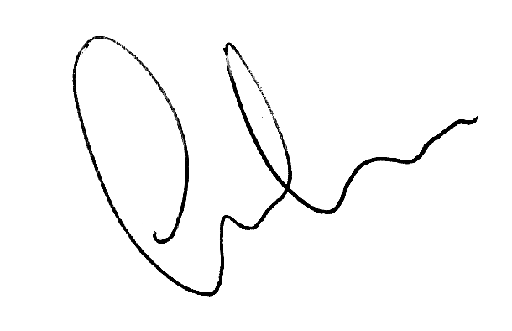

Clive Gross
Interim Chief Executive

