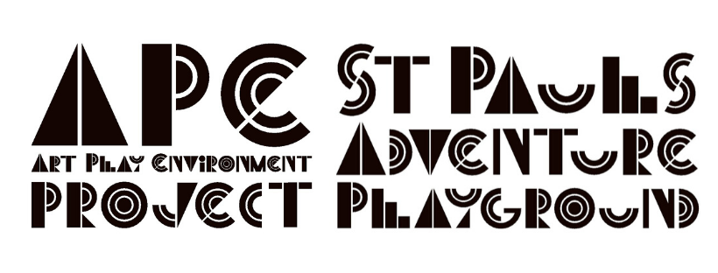
Executive Director of A.P.E. Project CIC Job Description

Salary: £35 - £40K depending on experience
Term: 2 year contract
Hours: 40 per week

A.P.E. Project CIC is an Equal Opportunities Employer, we welcome applicants from all diverse backgrounds.

Executive Director Job Purpose
The role will be the face of St Pauls Adventure Playground and will work alongside the board to oversee the development and implementation of the playground’s core programme of work, ensure the organisation is financially sustainable, developing a strategic plan, and that all legal requirements are met.

The Executive Director will also have overall responsibility for managing and supporting a staff and volunteer team to deliver the Open Access and SEND sessions and for leading on the development and implementation of a programme of Outreach work. The role will also lead on working with the local community to develop service and use of the playground, as well as developing strong partnerships at a local, city and national level.

Executive Director Job Duties
- Report to A.P.E. Project CIC’s board of directors.
- Develop a vision and strategic plan for the organisation in conjunction with the board.
- Inform the board of internal and external matters affecting the organisation.
- Ensure that the organisation's mission is being properly executed.
- Ensure the implementation of organisational provisions that strengthen the local community at all times.
- Develop, implement and evaluate the core programme of work within the Playground and in Outreach settings.
- Oversee the organisation's financial accounts and budgeting, including Purchasing and Ordering.
- Develop and implement a fundraising and income generation plan
- Support with Human Resource issues where necessary
- Lead the supervision process and motivate A.P.E. Project CIC’s staff members and volunteers.
- Be able to lead a team effectively, motivate, staff and volunteers, and develop a healthy culture.
- Develop and support fundraising activities within the local and wider communities.
- Provide written reports on a monthly basis to the Board.
- Serve as the face of the organisation in public relations matters.
- Prepare official correspondence concerning the organisation, including but not exclusive to press releases, social media or/and annual updates.
- Represent the organisation at community events, public events and activities on and off-site.
- Seek to expand the non-profit's community presence and public awareness of the organisation's services and efforts.

Executive Director – Person Specification
Essential
- At least 5 years of senior management experience, ideally in a charity, social enterprise or other not-for-profit organisation
- Proven leadership ability
- Successful fundraising experience, particularly in grants and contracts, and income-generation through trading
- Strong marketing and public relations skills
- Experience of managing a diverse team
- Good understanding and experience of finance management, budgeting and controls
- Knowledge and experience in HR issues
- Good communication skills, both written and verbal
- Strong interpersonal skills
- Highly motivated and self-sufficient
- Strategic development and business planning experience
- Integrity and understanding of ethical business practices
- Excellent organisational skills and experience of managing multiple projects simultaneously
- Problem-solving skills
- Good networking, partnership development and relationship-building skills
- Familiarity with the community or connection to a community similar to St Pauls
- Commitment to Equality, Diversity and Inclusion
- Entrepreneurial spirit
- Positive outlook
- Competent IT skills
- Ability and willingness to “get your hands dirty” and multi-task

Desirable
- A Degree in a related field, or related certificate equivalent or lived experience in a relevant management role.
- Have experience of, a passion for, and a deep understanding of play, youth and community work
- Experience and skills in outreach play or forest schools
- Creative approach
- Experience of working in a multi-cultural, inner-city environment
- Full driving licence

