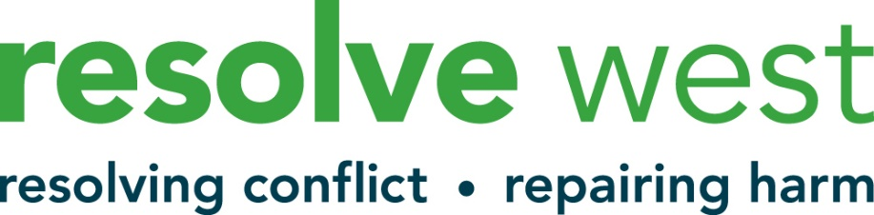

Confidential
Application to be Volunteer Conflict Resolution Practitioner

PERSONAL DETAILS

Name
Address
Postcode
Telephone
Email

Where did you hear about Resolve West?

Please tell us a bit about yourself, (Please tell us about your experience in work and/or volunteering, or some other life experience, or your background, your home situation or perhaps about what interests you)

Please tell us about any current or previous paid or voluntary work that may be relevant to this role.
Please tell us why you are interested in joining us as a volunteer?

Are you available to volunteer? (We work with clients during the daytime, evening and sometimes at the weekend – what times are you most likely to be available in the future? E.g. “in the evenings” or “only ever during school hours”. We don’t need you to commit to specific times, but we do need to know that you will have capacity and time to fulfil the role.

Do you have all the qualities and skills listed on the Practitioner Job description/person specification enclosed in the Application Pack?
YES / NO (please delete)

Are you able to travel around Bristol and surrounding areas to visit clients?
YES / NO (please delete)

Are you over 18 years old?
YES / NO (please delete)

Do you agree to commit 96 hours per year of your time for a minimum of 1 year?
YES / NO (please delete)

Please let us know who we should contact (two referees)
If you are selected, we would like to hear from two people who are able to comment on your potential to become a volunteer. These might be someone who knows you well in a work role, or someone you know personally – but not family members.

Name: |  |  | Name
Email: |  |  | Email:
Phone: |  |  | Phone:
Address: |  |  | Address:
How do you know this person? |  |  | How do you know this person?

ACCESS NEEDS

Do you have a health problem or a disability that is relevant to this application? Do you have any specific requirements to help you access the training or volunteering role? Please give us details (you may prefer to contact us by phone to discuss this prior to making this application)

Data Protection (GDPR)
We take our duty to process your personal data very seriously. Our privacy statement explains how we collect, manage, use and protect your personal data. https://resolvewest.org/privacy-statement/

DECLARATION (see note below)*
You will be required as part of this post to undergo an Enhanced Disclosure and Barring Service check under the terms of the Rehabilitation of Offenders Act (1974).

Have you at any time been convicted of any criminal offence or been the subject of a caution, a bind over, or no case to answer? YES / NO (please delete)

If YES, please give details, including nature of offence on a separate sheet.

NB: The disclosure of an offence will not necessarily be a bar to your appointment.
(you may prefer to contact us by phone to discuss this prior to making this application)

I hereby declare that the particulars I have given on this form are correct and I understand that any falsification could give proper cause for dismissal.

Signed:
Name:
Date:

Please complete this form and the attached equalities form and return to:

sophie@resolvewest.org

Please contact Sophie, Volunteer Manager, at sophie@resolvewest.org for further information.

We look forward to receiving your application.

