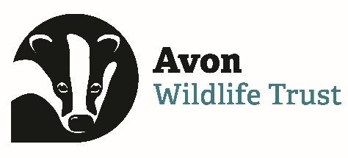

Application for post of: Community Organiser - Next Door Nature Somer Valley

Please complete and submit via our HR portal:  https://hr.breathehr.com/v/community-organiser-somer-valley-29738  Or to apply by post, send to: Confidential, HR, Avon Wildlife Trust, 17 Great George Street, Bristol, BS1 5QT  - Applications must be received by 30/05/23 8.30am | Application number:  (for office use only)

Personal Details
Name:

Address:

Contact telephone number(s)*:

Email:
* The Trust will use these with discretion – please state if you would prefer the Trust not to contact you at all by telephone

Present or Most Recent Employment
Employer’s Name and Address:

Position held:

Date started: | If you have left the above post, date of leaving:  Reason for leaving:
Current/final salary:
Please give a brief description of the duties and responsibilities:

Previous Employment
Start & Finish (MM/YY) | Name and address of employer | Position held and duties undertaken | Reason for leaving and final salary

References (Only to be contacted after interview, with your prior knowledge)
Name | Name
Address | Address
Tel no | Tel no
Email | Email
Position | Position

Academic Qualifications
Start & Finish  (MM/YY) | School/University | Qualifications achieved (incl. grade)

Professional Qualifications (e.g. Membership of professional institutions)
Date (MM/YY) | Qualification

Training (Include details of I.T. skills)
Date (MM/YY) | Course attended

Do you hold a current UK driving licence?

Personal Interests

Please give details of your relevant experience, knowledge and skills.
You may attach up to 4 additional pages of information, if necessary, marking them with your name and the title of the post for which you are applying.

How did you hear about this vacancy? (Please type ‘Y’)
AWT website Environment Jobs Countryside Jobs Service (CJS) Charity Jobs Third Sector Jobs The Guardian Jobs TWT website Indeed Reed Gumtree

Other (please state) …………………………………………………………………………………

If shortlisted, I would be available for a first interview on 24/05/23? Yes / No
If invited to a second interview, I would be available to attend on 31/05/23? Yes / No
Notes regarding availability:

I confirm that, to the best of my knowledge, the information given on this form is correct.
Signed: Date:

If you submit this application form electronically, without signature, you will still be regarded as confirming that to the best of your knowledge, the information given is correct.

The information you provide on this form will be used by the Trust only in accordance with General Data Protection Regulation (GDPR) (EU) 2016/679. Due to limited resources, the Trust may not be able to acknowledge applications or contact applicants unless they are invited for interview. If you have not heard from the Trust by the date of the interviews, you should assume that your application has been unsuccessful. If you wish to enquire about your application, please email the Trust using the address on the front of this form.

Thank you for your interest in working for Avon Wildlife Trust.

