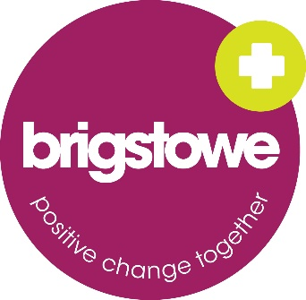
Application Form
The information you provide will be treated as CONFIDENTIAL and will only be seen by members of the Brigstowe/CAB who are involved in recruiting for this role

Please tell us your:
- Name:
- Address:

- Mobile Number:
- Email Address:
- Do you have the right to work in the UK? Yes ⇨ No ⇨

DISABILITY

- Do you have a disability that you would like to disclose?
Yes. No

- If yes, do you require any adjustments to attend an interview?
Yes. No

- If ‘yes’, please specify below any information you want to share about your disability and any adjustments to an interview that would be helpful:

REFERENCES

Please list two professional or personal references:

Full Name: |  | Relationship:
Company:
Address:
Email:
Phone: | Mobile:
Full Name: |  | Relationship:
Company:
Address:
Email:
Phone: | Mobile:

Notes:
- When completing this application form, please pay close attention to the requirements outlined in the person specification. Please continue on a separate page as necessary.
- CV’s will not be accepted. You should use the spaces on the second page to add all relevant info.
- In addition to this application form, please ensure that you also complete:
  - Equal Opportunities Form - Completion is optional and this does not form part of your application. This form helps Brigstowe/CAB to assess whether we are receiving applications from all sections of the community.

Please tell us about any experience from your adult life (e.g. having a family, volunteering, employment) which is relevant to this role.

Please tell us what communities and networks you are part of that will be helpful for the project as well as what is your relationship with them.

Please tell us why you are applying for this post, and how you meet the criteria. Please continue on separate sheets if necessary.
It is essential that you refer in detail to the role description, and tell us how your experience, knowledge, understanding or skills enable you to meet each of the points listed. Please give examples to illustrate your point.

Pls send this form, along with the Equal Opportunities form to cab@brigstowe.org by
Friday 16th June 9am

