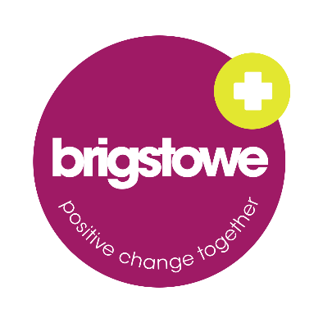

Application Form

As Brigstowe is committed to reducing inequalities, valuing diversity and enabling inclusion, this will be the only form we will be using for the first stage of short-listing. Please add as little personal info as possible on this application form. All personal information should be recorded on the “Required Information Form”. Please see the notes below for further information.

Notes:
- When completing this application form, please pay close attention to the requirements outlined in the person specification. Applications with no supporting information will not be considered by the panel. Please continue on a separate page as necessary.
- Don’t add your name, contacts or any info about yourself in this application form.
- CV’s will not be accepted. You should use the spaces on the second page to add all relevant info.
- In addition to this application form, please ensure that you also complete:
  - Required Information Form – This form will not be used by the shortlisting or interview panel
  - Equal Opportunities Form - Completion is optional and this does not form part of your application. This form helps Brigstowe to assess whether we are receiving applications from all sections of the community.

Please contact us if you have any queries.
WORK EXPERIENCE

EDUCATIONAL HISTORY

OTHER QUALIFICATIONS/TRAINING/VOLUNTEER EXPERIENCE

PLEASE OUTLINE HOW YOU MEET THE PERSON SPECIFICATION WITH EXAMPLES FROM YOUR PAID AND UNPAID WORK

WHY HAVE YOU APPLIED FOR THIS JOB? PLEASE USE THIS SPACE TO TELL THE PANEL ABOUT ANY OTHER INFORMATION THAT YOU THINK WILL BE USEFUL

