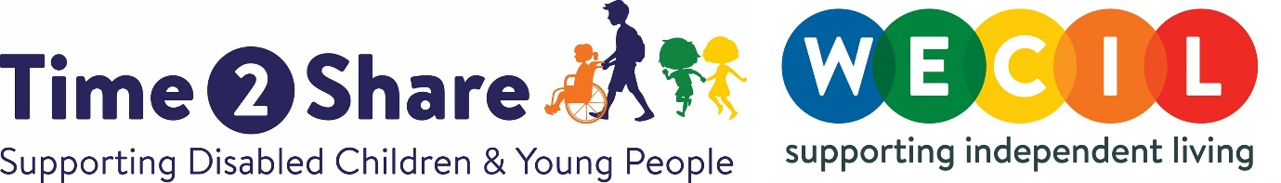

Volunteer Befriender Role Description

There are children and young people across Bristol looking for a Buddy to spend time with and have fun! If you can spare 2 hours per week and are aged 18 or over, we need your help! We are currently processing applications for volunteers to support disabled children and young people in Bristol in response to the high level of parents and carers requiring this service.

About Time2Share@WECIL We are a local charity supporting disabled children, young people and their families across the Bristol, Bath and North East Somerset region. We have been successfully supporting people to access volunteer befriending services and group activities in the area for over 40 years. This would not be possible without the support of our volunteers and we are currently recruiting so that we can continue this great work and reach out to more families.

About the role Our 1:1 befriending service involves volunteers spending regular time with a young person doing something they both enjoy such as watching a movie, cooking, playing football or going for a walk. Spending just a couple of hours a week with a befriender can make a dramatic difference to the lives of disabled children and the people who care for them. It can enable young people to increase their confidence and independence, develop their life skills, become less isolated, build their own friendships and of course have fun! It also provides parents and families with the chance to have a break from their caring responsibilities.

What we are looking for Our volunteers come from a wide variety of backgrounds and ages and you do not need previous experience of working with children or disabled people to become a befriender. If you are enthusiastic, committed, responsible, have a positive attitude and think you could be a good role model then this could be the ideal volunteering role for you! All we ask is that you spend regular time with a young person and try to commit to befriending for one year.

What you can expect Befriending can offer a unique chance to have fun with a young person and make a positive impact on their life, at the same time as developing new skills, knowledge and experience. It is very important to us that you are linked with a young person that shares your interests and you are happy to spend time with, and we do everything we can to help you feel confident and comfortable in your volunteering role. To help achieve this we provide:
- Induction training and ongoing training/development opportunities
- Ongoing support and advice from our Volunteer Co-ordinators
- Expenses paid

Time2Share@WECIL is committed to the safeguarding and the welfare of children and young people and expects its staff and volunteers to share this commitment. All volunteering roles will be subject to our safer recruitment process including undertaking of references and an enhanced DBS check.

To Apply please complete the following application form: https://form.jotform.com/200623458663052

