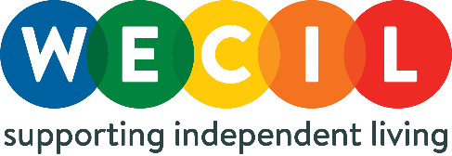
Befriending Administrator
Person Specification

Essential:
- Good standard of written English
- Recent administrative experience
- Excellent customer service and telephone skills.
- Good written and oral communication skills.
- Ability to work independently and as part of a team
- Desire to learn and willingness to develop in the role.
- Organisational skills with the ability to handle a busy, varied workload and to cope with interruptions and changes.
- IT skills including Office 365 systems to produce letters, spreadsheets, reports, and maintain databases.
- Ability to be resourceful, research, gather and distribute information as necessary.
- Ability to promote WECIL and its services to clients and partner organisations.

Desirable:
- An understanding of the social model of disability.
- An understanding of a Befriending/Buddy volunteer model
- Experience working within administrative roles for volunteering projects.
- An understanding of the barriers faced by Disabled Children, Young People, and their families.

