Being a Trustee for Changes Bristol
About Changes Bristol

Changes Bristol began in 2003 when people with lived experience of mental health issues came together to form a support network that was not available in Bristol at the time. People felt a peer support network using their own experience of mental health would inform each other and would be empowering, and that lived experience was a valuable asset to support others.
A support group was set up in 2003 which became over-subscribed and very successful and our founder Richard Pearce set up an Association in 2005 and we became a charity in 2007.
In 2017 we became a Charity and Company Limited by Guarantee.
The ethos of the charity is of a grass roots organisation that has grown due to the needs of the community. People with lived experience and those that use our support groups are the life and soul of the charity and help to guide and develop the charity and its services.
In 2003 we had one peer support group, we now have 18 peer support groups, both face to face and online. All our support groups are facilitated by trained volunteers with lived experience to ensure the meetings are safe, empathetic and non-judgemental. We have over 40 volunteers helping to run the service and the equivalent of 5 full time members of staff.
In addition we have set up new services in the last two years with a 1 to 1 befriending service and a Walk and Talk service with 2 full time equivalent members of staff and over 65 volunteers. Our response to COVID has been to be more agile and create new services for the needs of our community.
Our charity helps over 600 people every year, with over 4,000 visits to our meetings and 150 people being helped by our befriending service.
We also run various workshops, volunteer opportunities and training.
Our administrative office is at the Barton Hill Settlement in Lawrence Hill; however, our support meetings are held at community venues in different areas of Bristol so the service is as near to people as possible.

The Role of a Trustee
The Board of Trustees is the governing committee that is responsible for the financial and legal status of the charity. It oversees what the charity does and sets the strategic direction of the charity.
We currently have 10 board members. We have several vacancies we would like to fill to strengthen the skills and abilities of the board.
The Board of Trustees usually meets once a month, every second Wednesday of each month, 6:30pm to 8:30pm, and meet at the Barton Hill Settlement or online. All trustees are emailed staff reports 5 days before the meeting and an agenda is sent out the day before the meeting. Trustees and staff can add items to the agenda and help shape the discussions.
Our Board works on the basis of a team, working together with a common goal to improve the charity and its service for the long term. Although the Trustee meetings are formal events, they are also friendly, relaxed and productive.
Minutes are taken by our Trustee Secretary who emails out the minutes and any actions from the meeting approximately 7 days later.

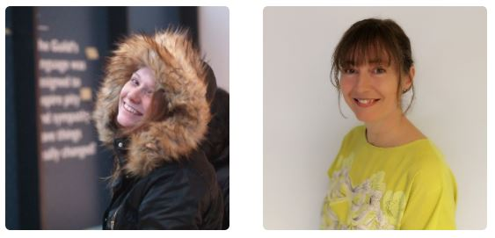
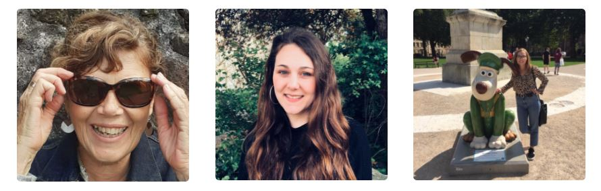

What is expected of a Trustee?
Trustees are expected to learn about the charity and understand their role as a trustee. Guidance will be given by the board and we encourage new trustees to go on a Voscur course (usually 2.5 hours long) which explains the legal and strategic role of a trustee.
Trustees are expected to turn up to the monthly meetings. If you are not able to be at a meeting, apologies should be given.
We expect trustees to bring their own particular skills and knowledge to the board and take part in the discussions taking place and help decision making for the charity.
Each trustee meeting has an agenda which is followed and is led by the Chair of trustees. Reports produced by the staff are discussed and the trustees can ask questions to ensure they understand any issues and for decisions to be made.
In effect, this requires about 4 hours volunteering a month as a minimum.
Trustees are encouraged to take ownership of actions between meetings, this is usually based on the skills or interests of the trustee and may be as simple as emailing someone or could be to lead on a project. This is all subject to the time that individuals can devote to the charity.
Depending on the skills, experience and interests of the trustee, the trustee can get further involved and lead or be involved in a committee or project. For instance, we have a Fundraising committee, marketing committee, and a group looking at policies. In addition, it is useful for Trustees to represent the charity from time to time at events and using their own social and business networks to raise awareness of the charity.
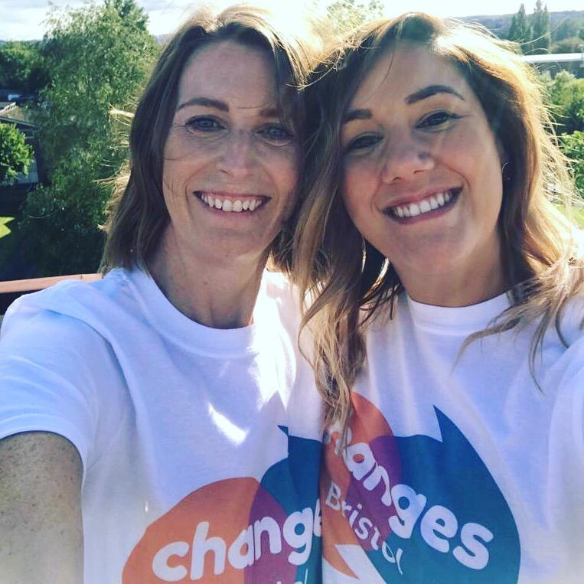
Below are comments from a previous trustee about how they have found the role:
I originally made contact with Changes when I saw on a local neighbourhood bulletin board that they were looking for new trustees. I have to admit to being quite nervous about applying as I wondered how I could really help out. Turns out I couldn’t have been more wrong! From my first meeting with Jason (Project Manager) when he came to present to my team at Lloyds, I knew I wanted to try and get involved to help this amazing charity. When I heard about the amount of people they support and the groups that they offer on basically donations and grants, I was so impressed and was keen to get involved. I mentioned to Jason that I was unsure about whether my skills would be useful but, after an informal planning session in the pub, I realised that there were definitely things I could offer to the charity.
Since then, it’s been an absolutely great experience and something I am so pleased that I did. My involvement with the charity has covered the following over the years:

· Monthly trustee meetings lasting 2-2.5 hours
· Ad-hoc planning meetings
· 6 – 8 weekly fundraising meetings lasting approx. 2 hours
· Attending events in spare time to show support (talks, fundraisers)
· Getting friends and family involved in events (Bristol and Bath half marathon for example)
· Using my network from large corporates to make introductions

This isn’t an exhaustive list but gives you a rough idea. There have been occasions when I haven’t always been able to attend trustee meetings or be quite as involved and the board has always been understanding so there is no need to worry if other commitments crop up from time to time. All of the trustees are made to feel very valued and there is genuine appreciation for the time that we give up.
If you have an interest in mental health and would like to get involved with an amazing local charity, then go for it!

Skills required
We value a range of skills that can be brought to the board and we very much welcome people who have direct or indirect lived experience, and people from diverse backgrounds. The most important attribute of people that get involved with our charity is that they have an enthusiasm for improving mental health and the role of lived experience and peer support.
Quite often people have many skills that people undervalue which are extremely valuable to the board of trustees such as thinking through problems analytically; having a wide network; experience of delivering projects; having an eye for detail; being able to think outside of the box and working in a team environment.

Other areas of experience that are sought after are:
Fundraising
Entrepreneurial experience
Knowledge of HR
Network of contacts in small/medium sized businesses and/or corporates
Knowledge of the Mental Health sector
Knowledge of Compliance
Legal Knowledge
Experience in developing and implementing risk management systems
Strategic development
Project management
Social media expertise
Marketing
Public Relations
Financial Literacy
People management skills
Management
Statistical analysis
Knowledge of statistics and monitoring systems
Information technology and CRMs
If you feel that you would have something to offer the board of trustees and can commit to at least a 12 month term as a board member, please do get in touch with us at info@changesbristol.org.uk

