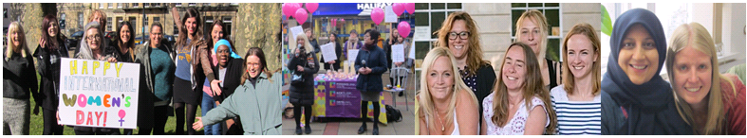
Female* Black, Asian, Eastern European or Ethnic Minority Independent Domestic Violence Advisor
Part-time Permanent Contract

We have a rewarding opportunity available for a Female Black, Asian, Eastern European or ethnic minority Independent Domestic Violence Advisor (IDVA) to join our team based in Bristol. You will join us on a part time, permanent basis working 26.25 hours per week and in return, you will receive a competitive salary of £24,496 (unqualified) or £25,878 (qualified) per annum (pro rata for part-time staff) plus benefits.

Established in 1999, Next Link is the leading provider of domestic abuse services to women and children in Bristol, South Gloucestershire and North Somerset. At Next Link we are committed to providing holistic, empowering and personalised support and advocacy to survivors experiencing domestic abuse. With a focus on survivor’s safety and recovery, we believe the provision of flexible support tailored to survivor’s needs can be transforming, helping to maximise independence and self-determination so survivors can make informed choices.

In return for joining us, we will offer you:

- Up to 30 days annual leave (depending on length of service)
- 3 extra holidays including International Women’s Day
- Excellent development and training opportunities
- Employer pension contribution (minimum 5% of your gross salary)
- Mindful Employer Plus Scheme
- Cycle to Work Scheme
- Long Service Awards
- Wellness Awards

About the role:

We are looking for a Black, Asian and Eastern European or Ethnic Minority Independent Domestic Violence Advisor to join the team and work within a dynamic, fast-paced crisis intervention advocacy and support service. You will provide a crisis response service to Black and Ethnic Minoritised survivors experiencing domestic abuse and in need of help and support to become safe.

Key duties and responsibilities of our Black and Minoritised Independent Domestic Violence Worker

- Responding to emergency /crisis situations to survivors experiencing domestic abuse
- Providing support, advice, advocacy, signposting and direct intervention
- Providing short term support (up to 8 weeks); advising survivors on criminal justice/ and civil remedies
- Empowering survivors to increase their options, make positive choices/decisions, increase their confidence, safety and recovery
- Some evening and Saturday working on a rota basis and participation in an out of hours telephone on-call rota

This is not an exhaustive list of your duties and outlines the general ways in which it is expected you will meet the overall requirements of this post.

What we are looking for in our ideal Black and Minoritised Independent Domestic Violence Worker:

- Experience of working with people in crisis
- An understanding of the impact of domestic abuse on survivors
- The ability to deal with and diffuse crisis and emergency situations in an effective manner
- Experience of risk assessment, co-producing risk management and safety plans
- Experience of managing own caseload
- A full driving licence and access to transport

If you are motivated, resourceful and passionate about empowering survivors of domestic abuse, please apply now to join us as and contribute to the valuable work of Next Link and its wider services, delivering hope and support to survivors of domestic violence and abuse.

How to apply

Please download the application pack from our website and complete the application form. Please submit your application by 9am 27th April 2023. Please do not send CVs. Interviews will be held on 28th April 2023

www.nextlinkhousing.co.uk HR.Enquiries@missinglinkhousing.co.uk

Next Link is committed to safeguarding and promoting the welfare of children, young people and adults at risk of abuse, and expects all staff and volunteers to share this commitment. Missing Link is committed to Equal Opportunities. *Due to the specific requirements of this role, this post is exempt under the Equality Act (2010), Part 1, Schedule 9 (Genuine Occupational Requirement.)

