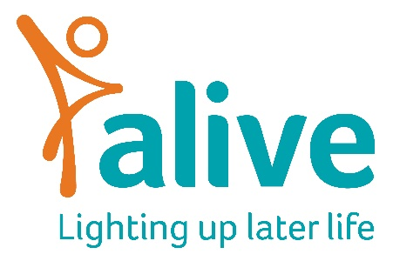

Job Description
Position: Building Mental Health Resilience Project Manager –
18 months Fixed Term Contract
£25,000 Pro Rata, 0.6 FTE (3 Days per week)
Reports to: Community and Technology Project Manager
Overall Job Purpose:
- To coordinate the ‘Building Mental Health Resilience’ Project and see through from beginning to end.
- To work with community groups to develop training courses that help them understand how to manage and improve their own mental health.
- Work with wellbeing practitioners to test and trial therapies popular with older people.
- Work with our internal videography and design teams to produce training resources.
- Work with our Volunteer Co-Ordinator to train volunteers to deliver this training past project end.

Main duties and responsibilities:
- Recruit community groups to participate in the project
- Deliver thee training courses to three community groups, continually improving content through co production
- Recruit and manage wellbeing practitioners
- Monitor and evaluate the sessions using appropriate evaluation tools and share our learning throughout the adult care sector, where appropriate
- Hold regular project management meetings with relevant staff and external partners and produce progress reports as required
- Develop any promotional material required for the projects
- Utilise relevant performance and evaluation tools to monitor, measure and report on the impact of the projects
- Manage the project budget, keeping accurate records of expenditure
- Work with the Marketing & Projects Manager to develop marketing and social media content
- Make recommendations on lessons learned from pilots and on how successful projects can be extended or turned into regular services

Person specification:

Experience

Essential:
- Experience of writing and delivering training
- Experience of working with and booking workshop facilitators.
- Developing, managing and coordinating projects successfully
- Understanding the principles and practices of providing person-centred, co-produced and accessible services
- Working with any one or more of the following groups/settings: Older people, community groups, carers, mental health support.
- Producing appealing promotional communications

Desirable:
- Working in the voluntary sector in either a projects, services, marketing or business development role
- Working with underrepresented groups in Bristol
Skills and Knowledge:

Essential:
- Knowledge around mental health
- Skills in facilitating groups, ensuring every member has the chance to be involved
- Great relationship builder with strong inter-personal skills
- Excellent record-keeping and budget management skills
- Ability to establish good working relationships with staff, management, volunteers, family members and local communities
- Ability to multi-task, prioritise and take the initiative to solve problems
- Strong organisational skills, with attention to detail
- Ability to work independently, proactively and under own initiative
- Excellent written and verbal communication skills and phone manner
- Computer literate and familiar with using common Office (365) programmes

Desirable:
- Knowledge around older people’s mental health
- Educated to degree level or equivalent experience

Project management qualification or course attendance
- Training qualification or course attendance

Personal attributes

Essential:
- A self-starter, able to work independently, on their own initiative, and as part of a team
- Organised and able to multi-task in a busy open plan office
- Creative thinker who can develop new ideas and turn them into action
- Passionate about improving the lives of vulnerable older people
- Flexible and adaptable
- Positive and enthusiastic outlook
- Friendly and approachable team player
- Ability to create a warm, safe, welcoming environment and foster positive relationships for older and young people alike

Other requirements
Essential:
- To have to ability to travel across Bristol without relying on public transport.
- Willingness to travel across the area covered by the projects

Desirable
- Portable online DBS (enhanced disclosure)

Terms and Conditions of employment

Salary: Up to £25,000 p.a. pro rata depending on experience, plus pension. Salaries are paid monthly in arrears and reviewed annually.

Conditions of employment: This is a fixed term role on 3 days per week (0.6 FTE) over 18 months. We work a 7.5-hour day. Annual holiday allowance is 25 days plus Bank Holidays pro rata.

Freelance training opportunities may be available with Alive on top of this work, delivering Alive core training to care homes and carers. This will be dependent on training bookings and paid at Alive’s usual freelance rate.

Location: Alive is based at the Create Centre, Smeaton Road, Bristol BS1 6XN. The role will require regular travel around Bristol and this will require your own transport.

Training: You will be encouraged to attend Alive sessions on a regular basis in order to understand and communicate what we do more effectively.
Please note: This job description is for guidance. Employees are expected to be flexible and co-operative and to undertake additional duties as required.

