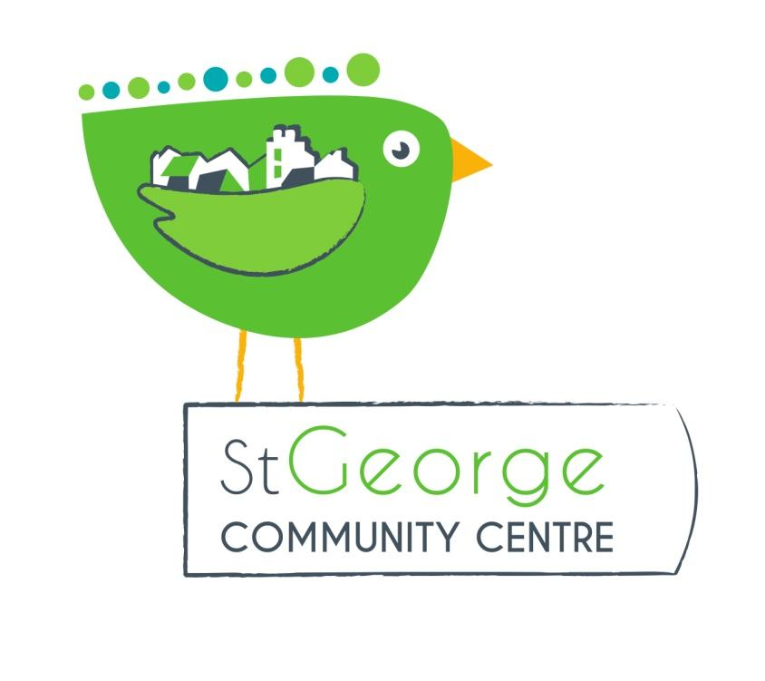

Role Title: Volunteer Chairperson and Trustee St George Community Association (SGCA)

Purpose/ summary of role

Provide leadership to St George Community Association and management committee by ensuring that the association remains focused on the delivery of the organisation’s charitable purposes providing an organisational and practical resource for the community of St George.

Tasks

Chairing and facilitating committee meetings

Giving direction to organisation policy-making

Checking that decisions taken at meetings are implemented

Representing SGCA at functions and meetings, and acting as a spokesperson as appropriate

Bringing impartiality and objectivity to decision-making

With the other trustees:

Planning the annual cycle of committee meetings and other general meetings where required, for example annual general meeting

Setting agendas for other general meetings

Developing the board of trustees including induction, training, appraisal and succession planning

Addressing conflict within the organisation, and liaising with SGCA Trustees, staff and volunteers to achieve this.

Liaising with the committee to keep an overview of the organisation’s affairs and to provide support as appropriate

Leading the process of supporting and appraising the performance of staff.

Sitting on appointment and disciplinary panels
- Serve as a Director of the SGCA company limited by guarantee, alongside the treasurer and Secretary.

Person specification
In addition to the person specification for a trustee, the chair should have the following qualities.

Leadership skills

Experience of committee work

Tact and diplomacy

Good communication and interpersonal skills

Impartiality, fairness and the ability to respect confidences.
It would also be desirable for the chair to have knowledge of the St George area and community as well as a wider involvement with the voluntary sector and local community networks.

Time Commitment
We would expect the Chair to commit to the role for a minimum of 12 months. We would expect that the Chair would need to commit 3-4 hrs a week in this role.

Support Available
The Chairperson is a very important role in the organisation, and will work closely with the treasurer. We have a very active and supportive committee who will assist as required.

Benefits to volunteer
This is a great opportunity to contribute to the work of St George Community Association if you have experience of, or are interested in . The treasurer’s role is essential for making sure our organisation runs successfully and continues to provide an affordable community venue for local residents.

Application Procedure
Informal interview with the current Chair and other members of the committee as appropriate. We will also require satisfactory references.

Background Information
St George Community Association is a registered charity and not-for-profit company limited by guarantee. It was set up in 1987 by by a group of local residents who felt that there was a need for a community centre in St George. They originally met in a local library and held events in St George Park. After many years of campaigning a local building was found on the site of the old grammar school canteen. The building was in complete disrepair and eventually, in 1995, grant aid was given by Bristol City Council and the new Community Centre was built.

The organisation has a Community Asset Transfer from Bristol City Council, who lease us the building rent free. In return we look after and run the building for the benefit of residents in St George. This means that all hire income is used to maintain the centre and develop new community activities.

Our turnover is currently around £20,000 per annum with additional grant funding for events or improvements. The bulk of our income comes from our regular hirers, followed by weekend parties and special event bookings. We apply for small grants for specific projects e.g. replacing the flooring in the main hall, new signage. We raise a small amount from community events such as our Christmas Fair, Table Top sales, Family fun days etc.

Our volunteer committee of local residents runs the organisation. The Chair, Treasurer and Secretary also serve as Directors of our company limited by guarantee We have a paid manager for 20 hours a week. Arrangements for cleaning and maintenance.

