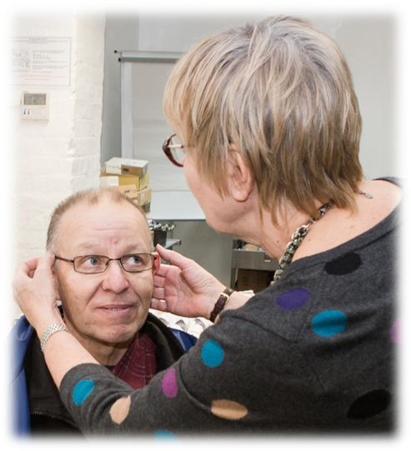
VOLUNTEER ROLE DESCRIPTION

Role: Clinic Manager
Location: At one of our clinics (often based within a homeless centre).
Expected Commitment: Initially weekly for every clinic. Around 16-20 hours per month.

Summary: We need someone to manage the clinic. You do not need opticians experience for this role, just an ability to learn the practicalities and procedures of running an opticians clinic and aptitude in using online systems.
Our clinics are staffed by optometrists who undertake the sight tests. To operate efficiently, each clinic also needs one or two assistants to meet patients record their details and help them to choose spectacles. The assistants operate online systems, entering patient details and record spectacle dispensing and ordering. This allows the optometrist to focus on the clinical aspects of the service.
The Clinic Manager looks after all the administrative and practical aspects of running the clinic, inducting new clinic assistants, and ensuring the clinic runs smoothly.
The Clinic Manager is often assisted by further operational volunteers doing specific tasks, such as:
- Clinic Equipment and Supplies Fixer
- Patient experience and feedback volunteer
- Online Administrator – Opticians patient and NHS systems / Claims

How you will start
If you are new to working in an opticians, you will start your work as a clinic assistant to learn the ropes. Supporting the optometrists, you will be welcoming patients, registering them, helping them to choose spectacles, ordering, fitting and repairing glasses. We will provide full training for the role.
Soon you will take on the wider practicalities and administration of running a clinic, as clinic manager. You will train and support the clinic assistants to ensure all administrative procedures are completed and the clinic runs effectively from week to week.
You may be a Dispensing Optician or Optometrist, in which case you will have a good understanding of the role already. We will train you on our online patient management system and how our clinics operate.
Once you are trained and confident in the operation of the clinic, your role will become more supervisory and managerial.
Initially you will need to attend weekly to learn how the clinic runs and to supervise new volunteers. Ideally, you will continue to attend every week, although your aim will be to train up a deputy and team of assistants who are able to run the clinic day-to-day. Then, you can attend to support the team as necessary and check the clinic is as it should be.

Activities
- Meet, interview, induct, train and supervise the team of volunteers and students who work in the clinic.
- Train and mentor the clinic team to deliver accurate and complete clinic processes, excellent service and good communication with patients, centre staff and volunteers.
- Ensure all administrative and clinic standard procedures are followed. (Professional optometrists are responsible for the clinical standards.)
- Monitor and control completion and processing of clinic activity, tracking, ordering and NHS forms using online patient management system.
- Advise-on and troubleshoot problems with glasses, orders, collections and follow up of non-collections.
- Liaise with the clinic’s host centre on operational matters.
- Ensure clinic has everything it needs to run. Arrange for new stationery and supplies. Arrange upkeep of the clinic facilities, equipment and environment.
- Act as branch health and safety contact for receiving and processing concerns or incident reports. Co-ordinate local risk mitigation actions. Liaise with Operations Manager and General Manager on risk matters.
- Lead on occasional branch audits, such as local risk assessment, Quality in Optometry checks, infection control.

What are we looking for?
- You will need management and team leadership experience and skills. You do not need prior experience in eye care.
- You may be retired or semi-retired, but willing to learn management of a new function.
- You will need aptitude to learn our online Patient Management System called Blink.
- You will be someone who will take pride in making the clinic an efficient, structured and friendly service for our homeless clients.
- You will be highly organised, able to deal with all sorts and have empathy for homeless people.

What difference will you make?
You will be the lynch-pin of the clinic day to day. You will help introduce new volunteers to our community which will increase our ability to provide the service.
This is a challenging role involving learning new skills, troubleshooting and being part of a team which delivers a practical and important service for homeless people.
You will see the results of your work on the faces of clients when they receive a pair of glasses; often a really significant step in putting their life back together again after experiencing homelessness.
You will join a community of over 100 volunteers delivering this vital service in cities across England.

We are an NHS Service
- You will receive training on Safeguarding, Infection Control, Data Protection and the Blink patient management system.
- You will work with the volunteer professional optometrists who will maintain the clinical standards while you maintain all other standards.

