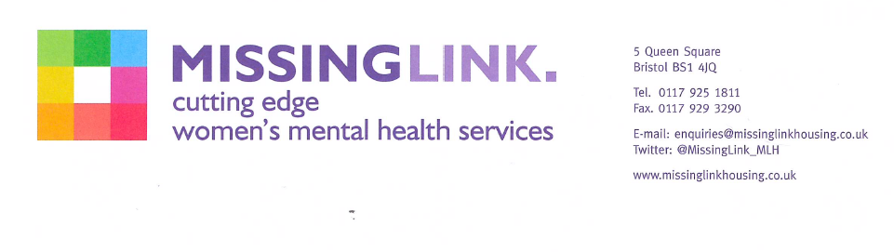

Dear applicant,

Re: Female Group Work Programme Coordinator

Thank you for enquiring about the above post.

Please find attached an Application Pack including; Job Description and Person Specification, Equalities Policy, Guidelines for Submitting an Application for a post, Application Form and an Equality and Diversity Monitoring Form.

We will be short listing on the basis of your experience and the requirements of the Person Specification. You will only be contacted if you are short listed.

Closing date: 9am Monday 25th January 2021
Interview date: Week commencing 1st February 2021

I look forward to hearing from you.

Yours sincerely

Human Resources Team
