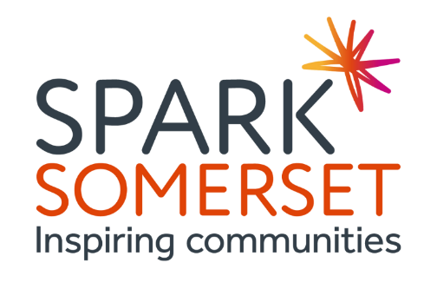

JOB DESCRIPTION
Development Manager - Volunteering
Full-time post (flexible/part time hours considered)
£32-34k (depending on experience)
Permanent contract
Accountable to the Head of VCFSE Development
6-month probationary period
25 days annual leave (pro rata) plus bank holidays
Flexible hybrid working from both home and in the office at Hambridge, as required

We’re on a mission to help change lives and build healthy, resilient communities in Somerset.

We do this by supporting and championing voluntary and community organisations and providing a range of services, training and advice. We also believe that everyone should have the opportunity to thrive and so we work with local partners to provide volunteering opportunities for all.

Pivotal to our success in this mission is our talented team of Development Managers, who work proactively to support local organisations and residents, driving quality across the sector and influencing local developments, creating opportunities for the VCFSE to grow and thrive.

You will bring strategic and operational volunteering experience and the ability to lead on the development of new volunteering initiatives, which may include supported volunteering, skill share and youth social action. We want to create an environment where volunteering can flourish in Somerset.

You will need to be flexible, adaptable and creative as well as tenacious and equally comfortable working with grass roots groups as you would be representing Spark and the wider VCFSE at strategic meetings.

Will you help us create a Somerset where anyone can make great things happen for their communities?

Key responsibilities

- Each of the Development Managers specialises in one or more of the areas outlined below. This role is specifically to lead on our volunteering support but will also include general information, advice and mentoring support to VCFSE groups and organisations in the following areas;

  - governance
  - legal structures
  - funding
  - policies & procedures
  - business/project planning
  - monitoring & evaluation
  - volunteering
  - evidencing impact & outcomes
  - networking & partnerships
  - assessing &managing risk
  - safeguarding

- To identify and provide a range of opportunities for VCFSE groups and organisations to develop their knowledge and skills to operate effectively e.g. hold workshops, share relevant documentation and information, create blogs and vlogs, and signposting to relevant external events and activities.
- Develop partnerships and work closely with other local agencies (including the public sector and health) to better support communities, stimulate new approaches and provide new development and learning opportunities for local groups: e.g. health, town and parish councils, social care, community partnership groups and other community networks
- Organise and host regular forums and networking opportunities for groups and communities which may be place-based, thematic or responding to need
- Work collaboratively with colleagues across the charity, including the Somerset Youth Work Alliance, Mental Health Network, Dementia Partnership and other internal projects.

General:

- To attend and actively participate in staff team meetings
- To accurately capture and record activities and support given on our CRM system.
- Keep abreast of changes in relevant policies and legislation
- To manage own time and workload effectively, whilst also working as part of a wider team
- To promote the mission, vision, values and strategic priorities of Spark Somerset
- Undertake any other duties that may be reasonably required by the CEO and the Board
- Promote and adhere to all policies adopted by the Board of Trustees

You will bring:

- Demonstrable operational and strategic expertise in volunteering with the ability to share knowledge and upskill other team members.
- The ability to be flexible and adapt to changing priorities, working at a grassroots level, and also managing strategic elements of the role.

- Experience of delivering accessible information, advice, and guidance activities within a VCFSE organisation.
- A sound understanding of the principles of capacity building techniques, asset-based community development and a commitment to co-production.
- Knowledge and understanding of the factors affecting VCFSE sector sustainability, both in internal and external.
- An ability to research a range of policy, strategic and operational information and provide practical, appropriate solutions.
- Experience facilitating meetings and events, online and offline.
- Excellent oral and written skills.
- A creative, lateral way of thinking and finding solutions.
- Initiative to manage time and prioritise workload.
- Good IT skills including Office 365 applications, CRM, social media, Zoom etc.
- Willingness to work occasional evenings and weekends with reasonable notice.
- The ability to travel across Somerset to relevant meetings and events.

We will provide:

- Flexibility and remote working options
- Open and friendly team environment
- Free Employee Assistance Programme

Diversity and inclusivity

A diverse voice is a more powerful voice. Diversity in our people brings new viewpoints and this drives debate and creativity, which is key to successful campaigning and an ability to engage new audiences. As such, we encourage applications from people who belong to groups which are often marginalised in society.

To apply

To apply, please submit your CV and an expression of interest explaining how your skills and experience meet the requirements of the role to recruitment@sparksomerset.org.uk.

For an informal chat about the role contact Sharon Hale on sharon.hale@sparksomerset.org.uk or 07817 646418 or Jenny Hannis on jenny.hannis@sparksomerset.org.uk No agencies please.

Closing Date: 12 noon on Wednesday 22nd May.
Suggested Interview Date: Wednesday 29th May.

