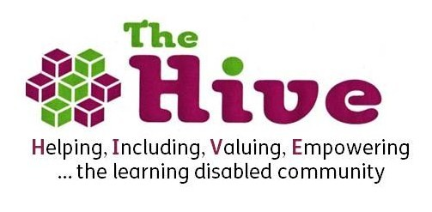

The Hive Drop-in Volunteer
Job Role and Personal Specification

Volunteer role: Support at The Hive Drop–in

Responsible to: The Hive Volunteer Co-ordinator & Chief Executive Officer

Hours: One session at drop-in either weekly or fortnightly.

About the Hive Drop in
The Hive is a small, local voluntary organisation whose aim is to support people with learning disabilities their families and carers in Bristol and South Gloucestershire.

The Hive Drop-in is a drop-in centre based at 322 Two Mile Hill Road, Kingswood, Bristol. It is a fun, friendly and safe place for adults with learning disabilities to socialise.

We provide a range of activities which people can either choose to be involved in or simply to attend and socialise with friends. Volunteers and staff are there to provide support where needed. There are many activities on hand namely a pool table, sensory room, Wii, Playstation, computers, TV room, games rooms as well as art and craft activities.

Job Role
- To support individuals to access activities
- To help facilitate arts, craft, quizzes, bingo and other games and activities
- To encourage independence and social skills amongst members
- To assist in the provision of refreshments
- Help prepare for the session by attending 10 minutes early to set up activities and to remain at the end of the session to help tidy up.

Personal Specification
- Commitment to helping others take control of their lives
- Non-judgemental attitude
- Willing to challenge discrimination and prejudice
- Commitment to equal opportunities practice i.e. challenging racism, sexism, ageism and disability
- Commitment to client confidentiality
- Patience, sense of humour, reliability, commitment, enthusiasm
- Good listening and verbal communication skills

