**EASY READ JOB ADVERT**

**"**

**"**

👀

**The Bristol, North Somerset, and South Gloucestershire Integrated Care System** has a new & exciting job opportunity - take a look!



Come and work with us as an **Expert with Lived Experience Co-Facilitator / Trainer..**

⑱

Are you **18** years or older?

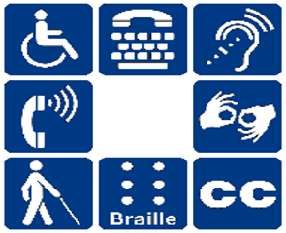

Do you have a **Learning Disability** (LD)?



Do you live here in **Bristol, North Somerset, or South Gloucestershire**?



Can you **talk in front of a group of people**?



Can you **use computer programs**?



Are you able to **travel to different training venues** across the region?



Are you good at **getting to places on time**?



Are you good at **working in a team** with other people?

If so we need you to help with the delivery of the **Oliver McGowan** training in **Learning Disability** to people who work in health and social care!

**In this job you will:**



Show **planning & organisational** skills



Help to develop & deliver **awareness training packages** to large groups of people



Talk & listen carefully to other people at work **& ask them questions**



Learn what needs to be said when delivering training & **share ideas**

We are committed to implementing **reasonable adjustments** for people with a learning disability.

We will be committed to your **training and development** from day one!

Our learning and development strategy includes all the ways that we can support you to ‘shine’ and excel in your role and is open to our staff at every level in our organisation.