Volunteer Application Form 2024
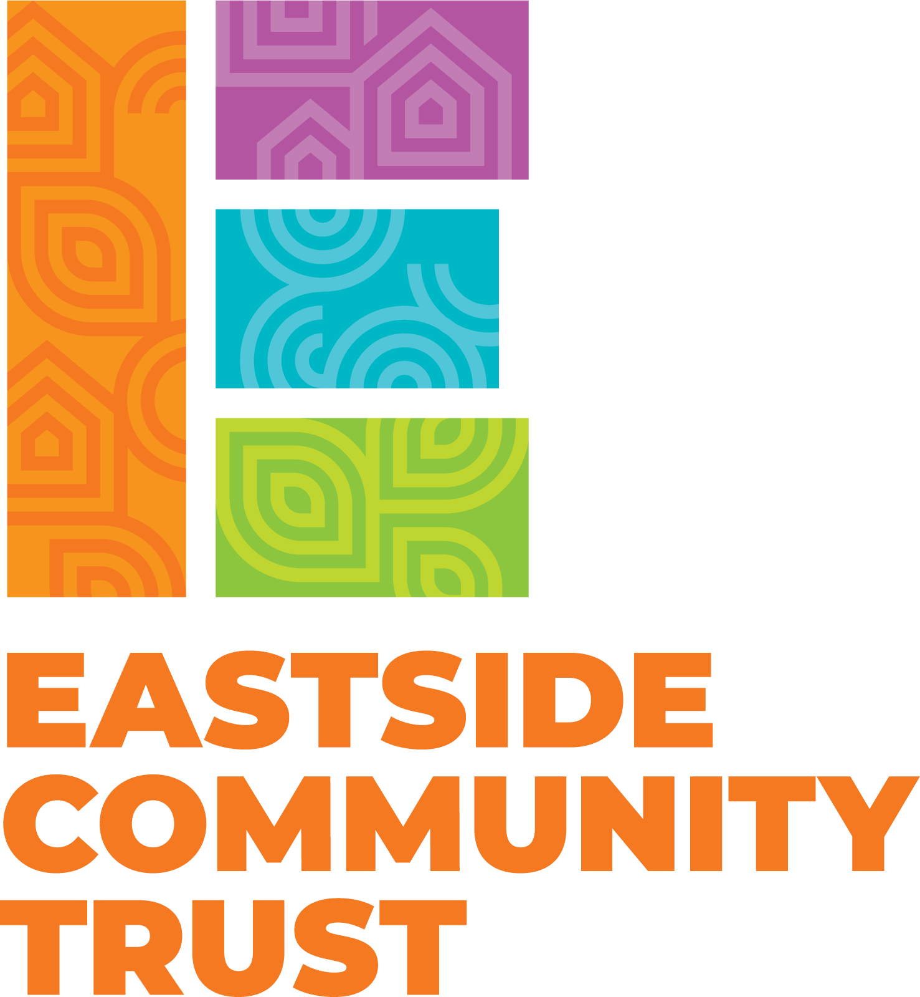

Thank you for your interest in volunteering for
Eastside Community Trust.
All the information you provide is confidential and will not be passed on to a third party.

Title |  | Forename(s)
Surname |  |  |  | Age
Address

Post code
Telephone
Email
Please tell us why you would like to volunteer for Eastside Community Trust (you can tick more than one box)
I want to help in my community |  | I’m interested in meeting new people
To gain experience for a course or employment |  | I’d like to share my skills and experience
I was asked by a friend |  | To develop new skills
To keep busy |  | Something enjoyable to do with my time
Any other reasons:

What kind of volunteering would you like to do? If you would like to offer an activity, please describe that here

Please tell us a little more about yourself and what experience, skills or qualities make you suitable:

Which days/ times are you available to volunteer? Please tick all that apply.

 | Mon | Tue | Wed | Thu | Fri | Sat | Sun
Morning
Afternoon
Evening

Do you need any materials?

What do you hope to gain from volunteering?

Volunteering status - The right to volunteer in the UK can be dependent on your citizenship and UK immigration status, so please make sure that you are allowed to volunteer on your visa.
Please tick to confirm that you are legally entitled to volunteer
Criminal records - Eastside Community Trust welcomes applications from potential volunteers with criminal records and will not discriminate unfairly on the basis of a conviction. However, some of our volunteer roles require a DBS certificate and we would inform you of this as part of the application process.
Would you be willing to undergo a DBS check if the role needs one (not all do)?
Declaration
I declare that the information given in this application is a true and complete. I understand that any offer of appointment and subsequent volunteering is subject to satisfactory references and satisfactory disclosure from the Disclosure and Barring Service.
Signature: Date:
Please return to: Eastside Community Trust, Easton Community Centre, Kilburn Street, Easton, Bristol BS5 6AW or email: contact@upourstreet.org.uk
Volunteer Confidentiality Agreement
By signing the Volunteer Confidentiality Agreement, you agree to the following:

- To keep all information about our work and in our contacts a secure place on site
- Not to divulge any personal or organisational information unless authorised to do so
- Information learned during the volunteering role should not be passed on to anyone outside of Eastside Community Trust
- If the role involves direct work with a community member or a particular service then any information acquired through the volunteering role should only be discussed with an appropriate person
- Any breach of confidentiality is viewed as a serious breach of trust and may lead to volunteer involvement being ended
- If a volunteer feels under pressure to breach confidentiality or have any queries about confidentiality, they should discuss this with a member of Eastside Community Trust staff

 | Volunteer | Eastside Community Trust
Signed:
Print:
Date:

Emergency Contacts

Name of contact

Relation to you

Contact Number

Email

Health and Wellbeing
Is there anything you think Eastside should be aware of to ensure your safety. For example, diabetes for which you take insulin, or a severe food allergy.

