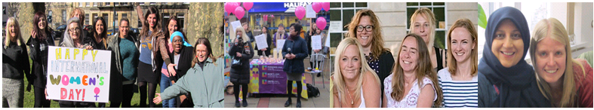

FEMALE* FAMILY SUPPORT WORKER – NORTH SOMERSET

We have a rewarding opportunity available for a Female Family Support Worker to join our team based in North Somerset. You will join us on full time, permanent contract, working 37.5 hours per week from 8.30am – 5.30pm with some additional evening and weekend work on a rota basis. In return, you will receive a competitive salary of £24,496 per annum and benefits.

Established in 1999, Next Link is the leading provider of domestic abuse services to women and children in Bristol, South Gloucestershire and North Somerset. At Next Link we are committed to providing holistic, empowering and personalised support and advocacy to women and children experiencing domestic abuse.

In return for joining us, we will offer you:

- Up to 30 days annual leave (depending on length of service)
- 3 extra holidays including International Women’s Day
- Excellent development and training opportunities
- Employer pension contribution (minimum 5% of your gross salary)
- Mindful Employer Plus Scheme
- Cycle to Work Scheme
- Long Service Awards
- Wellness Awards

About the role:

As our Family Support Worker, you will be working with families, in particular children and young people (CYP) aged 0 – 17 who may have experienced or witnessed domestic violence and abuse and are supported in Next Link’s Community services and accommodated within our Safe Houses.

Key duties and responsibilities of our Family Support Worker:

- Provide a high quality service and co-ordinated package of on-going emotional and practical support to CYP who are suffering effects from the trauma of, or have experienced domestic abuse
- Provide personal welfare support to CYP and to ensure that families in the safe house are provided with a safe, supportive and welcoming environment and to maximize the family’s safety when providing support in the community
- Responsible for co-ordinating and managing play and educational activities for children in the community and safehouses
- Work with children and young people to help them to become integrated into a new or existing community or safehouse
- Providing support for families through family court proceedings.
- Develop positive, trusting relationships with CYP of all ages and work in a child focussed way
- Liaise effectively and collaboratively with all appropriate agencies relating to CYP / family welfare
- Carry out assessments that effectively establish the support needs of CYP/ families using our services
- Complete a written support plan with the CYP and their mother
- Recognise, respect and address the needs of service-users who face particular barriers when seeking help to access the service, including those from different ethnic and cultural backgrounds

This is not an exhaustive list of your duties and outlines the general ways in which it is expected you will meet the overall requirements of this post.

What we are looking for in our ideal Female Family Support Worker:

- Ability to build and develop supportive relationships with abused women and their children maintaining professional boundaries
- Experience of carrying out needs assessments and delivering outcome focused support to families in an engaging and empowering way
- Ability to proactively organise and develop child centred activity programme that meets the needs of diverse CYP
- Ability to communicate effectively, both written and verbal, with a range of people
- Ability to work as part of a team demonstrating a flexible approach including a commitment to being part of a rota and on-call system
- Ability to be calm and resilient whilst under pressure and to remain optimistic and persistent
- A full driving licence and access to transport

If you are passionate about ensuring vulnerable women have a safe, comfortable place to live, please apply now to join us as our Family Support Worker and contribute to the valuable work Next Link and its wider services, delivering hope and support to survivors of domestic violence and abuse.

How to apply:

Please download the application pack from our website and complete the application form. Please submit your application by 9am on 13th February 2023. Interviews will be held on 17th or 20th February 2023.

hr.enquiries@missinglinkhousing.co.uk www.nextlinkhousing.co.uk

Next Link is committed to safeguarding and promoting the welfare of children, young people and adults at risk of abuse, and expects all staff and volunteers to share this commitment. Next Link is committed to Equal Opportunities. *Due to the specific requirements of this role, this post is exempt under the Equality Act (2010), Part 1, Schedule 9
(Genuine Occupational Requirement.)

