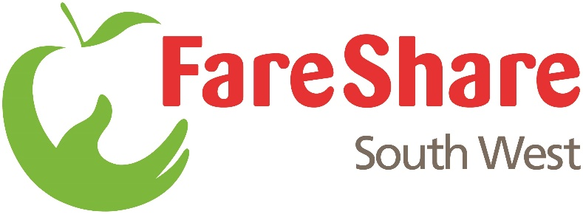

Fighting hunger, tackling food waste
Food Sourcing Officer
Reporting to: Food & Logistics Manager (FLM)
Salary: £21,892
Hours: 37.5 hours per week
Terms: Full-time, 1 Year Fixed Term Contract, 25 days Holiday (exc. Bank Holidays), 5% pension contribution
Work with: FareShare UK (FSUK) Food team, FSUK Regional Development Manager and
FSSW Regional Operations and Membership teams, Head of Compliance
Location: Bristol, Plymouth or Southampton based with regular travel & option of remote working

About FareShare South West:
FareShare South West is part of the national FareShare U.K. network of surplus food redistribution charities.

We fight food poverty by tackling food waste. We source quality surplus food – from food retailers, manufacturers, and suppliers – engaging volunteers to redistribute to local charities and community groups that provide meals to vulnerable people (individuals who are homeless, unemployed, socially isolated, recovering from addictions, etc.). Our food is a vital lifeline for children and families, people on low incomes, people who have lost their jobs, the homeless, refugees, domestic abuse survivors, the elderly, and keyworkers.

Purpose:
- To develop FSSWs network of local suppliers and further build relationships with those that already donate their surplus. Aligning with the needs of an increasing and diverse group of Community Food Members (CFMs), seasonal fluctuations in demand, and unforeseen emergencies, allowing FareShare South West (FSSW) to deliver against its charitable mission
- To ensure that our food is effectively and safely collected, stored, and re-distributed across a multi-site operation, utilising the most efficient routes, transportation solutions, and stock management.
- To support the FLM, FSSW Operations and Regional Membership Teams within the existing operational capacity of the Charity in effectively managing sustainable growth to align with charity-wide operational plans.
- To understand the differing needs of separate regions and support development of appropriate food and logistics solutions.

Local Food Sourcing:
- Support delivery of Local Food Sourcing Strategy to create a sustainable, growing, and long-term source of local & regional food to compliment food sourced by/through FSUK. This will include:
  - Research potential sources of food by geography, food type, and sector (retail, wholesale, producer, grower)
  - Programme of outreach work to establish contact, broker relationships (including on-site visits) and work with FLM to secure food supplies in line with infrastructure/growth plans
  - Support FLM working alongside other FareShare regional centres to share local food opportunities
  - Co-ordination of logistics to cost effectively receive surplus food.
- Supplier Engagement – working with Comms Manager to create regular content to engage suppliers, including impact, case studies, quotes, pictures etc.
- Lead internal reporting on food sourcing activity, working with FLM

Food management:
- Support FLM to manage ad-hoc food Offers from FSUK (non-Salesforce), manage the operational and storage capacity across all FSSW sites with growing/future demand and date of food.
- Work with warehouses and membership team to understand need of membership base, to efficiently allocate/manage unusual food and non-food offers.
- Ad hoc support warehouse staff and Heads of Region to raise food cases to FSUK where capacity is limited.
- Support regional teams’ engagement with national/local food suppliers.
- Manage the BAU PCP collections and Food Drives and support the FLM with developing store & FSUK relationships
- Monitor and report customer satisfaction/complaints and trends as applied to food

Logistics:
- Liaise with warehouse staff to ensure efficient use of the existing fleet of vans to maximise food collections across all sites
- Support FLM in use of a dedicated van/truck for food collections and movement of stock around FSSW sites
- Support the movement of stock across FSSW sites to ensure adequate stocks are in place to support order fulfilment, and ensure it is moved safely and compliantly

Administration/General:
- As needed, represent FSSW in local collaborations/partnerships addressing local food waste or surplus food e.g. Going for Gold.
- As needed, liaise with FSUK and other Regional Centres and be the main point of contact on matters related to food sourcing and logistics.
- Provide training for colleagues where upskilling is required.
- Provide FLM with timely updates on performance and produce a monthly Food & Logistics report.
- As needed, contribute to the preparation of annual budgets and plans
- Ensure that accurate and up to date food sourcing records (including future CRM) are maintained and are accessible
- Provide reports and information about activity, performance, and impact as necessary and upon request
- Work within national FareShare policies, procedures and adhere to legal frameworks
- Undertake administrative duties as required

Essential Requirements
- Clean driving license, access to a car and willing to travel
- Have exceptional relationship building skills with a range of stakeholders
- Be a strong communicator who is able to engage with a variety of audience
- Demonstrate strong problem-solving skills
- Self-manage your own performance and workload
- Have initiative and innovative thinking, in order to shape new/different ways of working
- Be organised, with a proven track record of achieving quality results
- Have strong IT skills and knowledge of Microsoft Office

Desirable requirements
- Level 2/3 Food Safety training is desirable, but training will be provided
- Experience working with or in the food industry
- Experience working in the third sector

