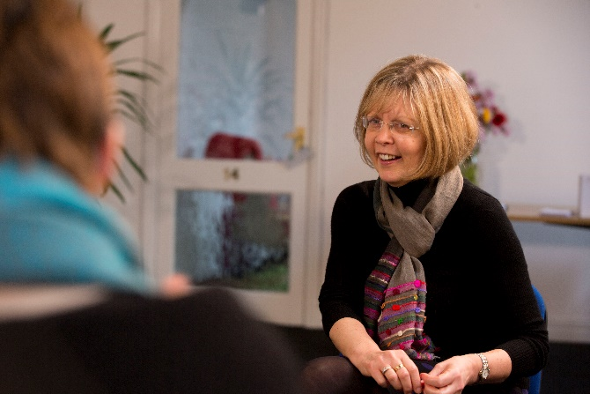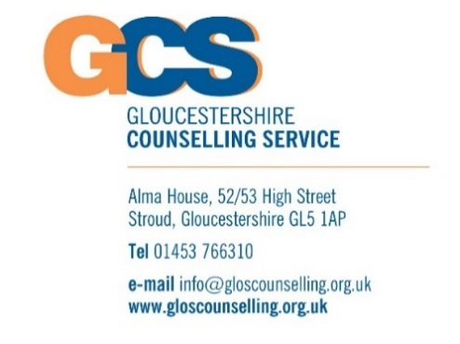

**Zoom Event July 18th 10.30 am – 11.30 am**

Use this time during lock-down to further your training and development.   
Register for our **FREE CCS Event by Zoom on July 18th 10.30 am – 11.30 am** if you are interested in developing your counselling & listening skills or starting to train as a counsellor on the Certificate in Counselling Skills Course this September.

A chance to find out more about training with GCS, our courses and meet others on-line as well as to ask any questions you may have about the training.

**Register for a place by contacting: Training.Bookings@gloscounselling.org.uk**

**To find out more about this event and the portfolio of training courses at GCS please visit: www.gloscounselling.org.uk/training**

**NEW FREE ON-LINE EVENT**

**Explore Training with GCS  
 Develop your Counselling & Listening Skills or  
Find out about training to become a Counsellor**



**www.gloscounselling.org.uk/training**[**Training.Bookings@gloscounselling.org.uk**](mailto:Training.Bookings@gloscounselling.org.uk)