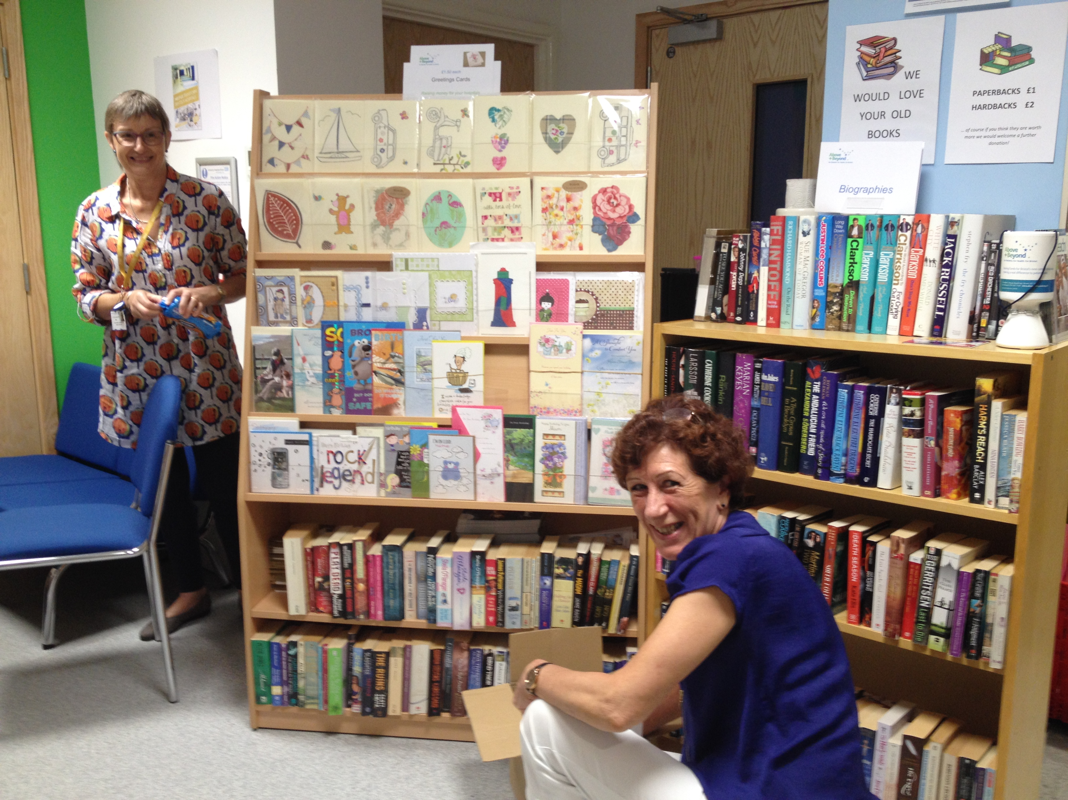

Fundraising Hub Volunteer

Role
Working in the Fundraising Hub within the Welcome Centre of the Bristol Royal Infirmary where staff, patients, their families and members of the public can come and speak to us and find out more about what we do. Open on weekdays between 10:00am and 5:00pm, with shifts of 10.00 -1.30 and 1.30 – 5.00, the role is to help build a welcoming atmosphere and raise funds for the Bristol City Centre Hospitals. Sales are currently second-hand books, cards & gifts and the role would also cover running bake sales and accept donations.

About Bristol & Weston Hospitals Charity

Bristol & Weston Hospitals Charity (formerly Above & Beyond) is doing great things to improve the health and happiness of every patient in all ten hospitals in the University Hospitals Bristol and Weston NHS Foundation Trust.

Together with our local NHS, we push the limits of what’s possible. We go above and beyond to transform the experiences patients have in our hospital, wherever the need is greatest. We bring moments of joy, comfort and hope to those who need it most. And we are committed to helping our hospitals go the extra mile for you and everyone who means the world to you.

Working for a charity feels great. Working for Bristol & Weston Hospitals Charity feels greater.

Location: Fundraising Hub at the Bristol Royal Infirmary Welcome Centre.
Skills and Experience: The role is flexible and would suit anyone who has a confident and outgoing personality and enjoys meeting people; someone with a welcoming and friendly personality, of smart appearance, who is reliable and has good attention to detail.
What we can offer:
- Full training for the role.
- Quarterly newsletters keeping you up to date on what is happening at Above & Beyond and how you have made a difference.
- Regular invitations to share your ideas and our plans.
- An invitation to our annual celebration event to say thank you.
Bristol & Weston Hospitals Charity is committed to ensuring everyone is treated fairly regardless of race, gender, marital status, disability, age, sexual orientation, religion or belief. We expect everyone volunteering on our behalf to share this commitment.

To find out more please contact: Lindsey Dowdell, Volunteer Coordinator on 0117 9926472
Email: lindsey.dowdell@bwhospitalschairty.org.uk
Website: www.bwhospitalscharity.org.uk/
Twitter: www.twitter.com/bwhospcharity
Facebook: www.facebook.com/bwhospitalscharity
Instagram: www.instagram.com/bwhospcharity/

