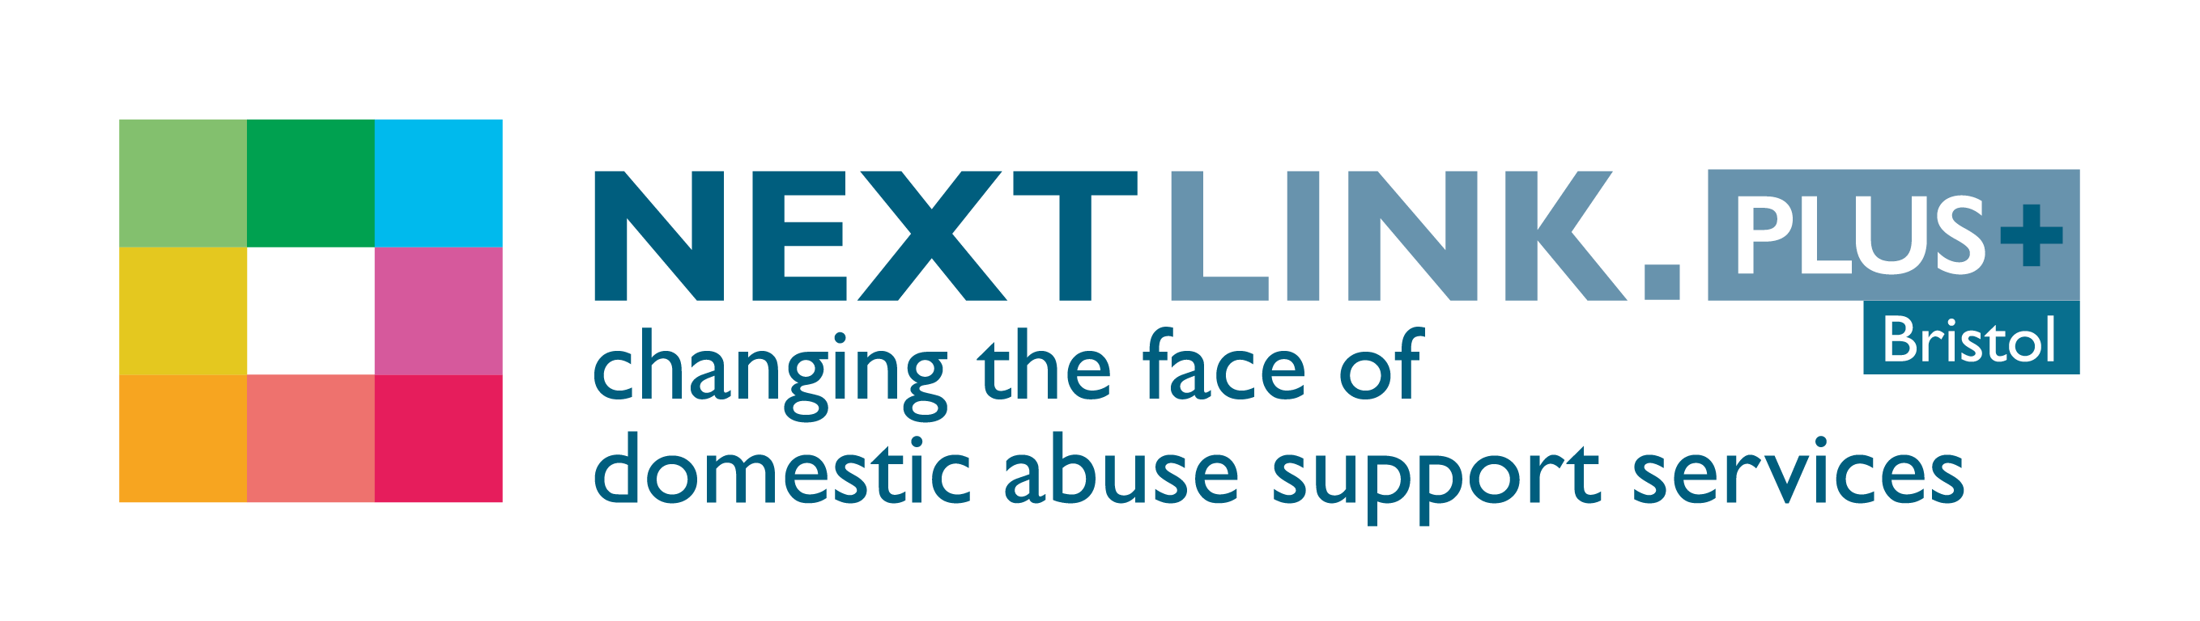
Female* Intern Safe House Support Worker
1 year Fixed Term Contract with opportunities for progression

We have been successful in getting new funding from Bristol City Council to provide the domestic abuse services in Bristol, and have a number of rewarding and exciting opportunities available for the right candidates to join our team.

We have a new rewarding opportunity available for a Female* Intern Safe House Support Worker to join our team based in Bristol. You will join us on full time, fixed term basis working 37.5 hours per week, this includes participation on out of hours telephone on-call rota and some evening and Saturday working on a rota basis and in return, you will receive a competitive salary of £22,369 per annum and benefits. We will offer you training and opportunities to progress to other roles across Next Link.

Established in 1999, Next Link is the leading provider of domestic abuse services to women and children in Bristol and South Gloucestershire. At Next Link we are committed to providing holistic, empowering and personalised support and advocacy to women and children experiencing domestic abuse. With a focus on survivors’ safety and recovery; we believe the provision of flexible support tailored to survivors’ needs can be transforming, helping to maximise independence and self-determination so survivors can make informed choices.

In return for joining us, we will offer you:

- Up to 30 days annual leave (depending on length of service)
- 3 extra holidays including International Women’s Day
- Excellent development and training opportunities
- Employer pension contribution (minimum 5% of your gross salary)
- Mindful Employer Plus Scheme
- Cycle to Work Scheme
- Long Service Awards
- Wellness Awards
- Facility to Work from Home once fully trained

About the role:

We are looking for highly motivated women to work as an Intern Safe House Support Worker within a dynamic fast paced team. You will be supported to develop the skills, knowledge and competencies to contribute to and assist in providing high quality safe house accommodation and support to women who have experienced domestic abuse with a victim centred approach, focussing on safety and recovery.

Key duties and responsibilities of our Intern Safe House Support Worker:

- Assist with the assessment of women / families referred to the service.
- Working alongside colleagues help carry out risk assessments including DASH, co-produce safety plans with the client’s, regularly review the plans, enabling women to assess and manage risk to their own and their children’s safety.
- Working alongside colleagues help carry out needs assessments which effectively establish the support needs of families and enable support to be offered as quickly as possible.
- In conjunction with the service user complete the empowerment star and draw up a support plan.
- Advise women on personal safety and safety procedures regarding the safe house.
- Enable and encourage families to take advantage of all services relevant to their safety such as legal advice, housing and benefits rights, education, medical treatment, counselling etc.
- Work in partnership with other agencies e.g. the police, local authority and drug/ alcohol advice agencies, health, social services, education, youth service and the voluntary sector to ensure efficient mechanisms for referrals and to advocate for survivors to ensure their needs are met.
- Safeguard the welfare of children, young people and adults at risk; working within Next Link’s safeguarding policies, South West Child Protection Procedures and local procedures for safeguarding adults at risk.
- Advise and support service users with the range of move on options available, draw up and deliver move-on plans.

This is not an exhaustive list of your duties and outlines the general ways in which it is expected you will meet the overall requirements of this post.

What we are looking for in our ideal Intern Safe House Support Worker:

- Numeracy and literacy to NVQ 2 or equivalent
- Empathy with the needs of victims of domestic abuse and vulnerable women with complex needs and the barriers they face
- Ability to maintain accurate and up-to-date records of contact with service users, other related information and to communicate with colleagues and stakeholders using common Microsoft Office packages, e.g. Word, Excel, Outlook and other IT software
- Ability to adhere to and set professional boundaries and recognise the need for personal safety, whilst establishing and maintaining strong working relationships with service users (training will be provided)
- Be available and committed to be part of the out of hours on call rota and work regular shift patterns during weekdays 9am – 8pm and some Saturdays
- A current, full driving licence and access to appropriate motorised transport

If you are passionate about ensuring vulnerable women have a safe, comfortable place to live, please apply now to join us as our Intern Safe House Support Worker and contribute to the valuable work Next Link and its wider services, delivering hope and support to survivors of domestic violence and abuse.

How to apply:

Please download the application pack from our website and complete the short application form. Please submit your application by 9am on 6th June 2023. Please do not send CVs. Interviews will be held w/c 12th June 2023.

www.nextlinkhousing.co.uk HR.Enquiries@missinglinkhousing.co.uk

Next Link is committed to safeguarding and promoting the welfare of children, young people and adults at risk of abuse, and expects all staff and volunteers to share this commitment. Next Link is committed to Equal Opportunities. *Due to the specific requirements of this role, this post is exempt under the Equality Act (2010), Part 1, Schedule 9 (Genuine Occupational Requirement.)

