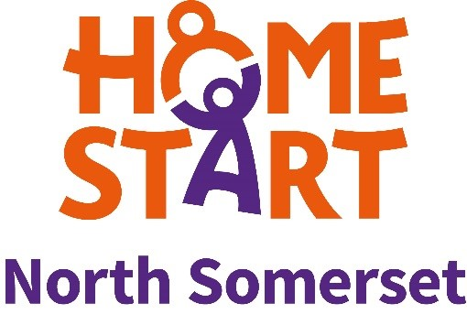

Home-Start North Somerset
Marketing and Fundraising Officer Job Description

Job Title: Home-Start North Somerset Marketing and Fundraising Officer

Location:
The Home-Start North Somerset
Currently homeworking. Office address as relevant is
Office Suite 3, Locking Road Business Park
110 Locking Road
Weston-super-Mare
North Somerset
BS23 3HF

Hours of work: 8 hours per week
(days and timings are flexible but to be agreed in advance of post starting)

Responsible to: Senior Organiser

Scope

Work particularly with the Home-Start North Somerset Senior Organiser and with trustees to implement the marketing and fundraising strategy both online and offline to raise awareness of the charity’s work and increase activity in the core areas of referrals, fundraising and recruitment of volunteers. Communication will be to all of Home-Start North Somerset’s stakeholders including current and prospective service users, volunteers, funders, healthcare services, the general public and businesses.

Main Responsibilities

The post holder will deliver an agreed programme of work, depending on current priorities for the organisation, in the following areas of work.

Content creation
Creating and designing content for all marketing channels using and expanding on suggestions from the marketing strategy.

Brand communication
Maintain the HSNS brand and core messaging across all channels and seek new ways to profile the brand and service.

Big projects and campaigns
Plan, implement and evaluate targeted marketing campaigns, for example new volunteer drive, e-newsletter sign up campaign, public fundraising campaign.

Fundraising
Contribute to raising an agreed target of fundraising as set by the Board on an annual basis, through contribution to trust and foundation applications, digital and live events.

Specific duties:

- Generate day-to-day content, expand and update social media and fundraising platforms. Develop platform profiles by improving content and increasing followers, likes and sharing.

- Develop digital fundraising opportunities.

- Work with staff team to collate and write content for scheme newsletter. Increase numbers signed up to newsletter.

- Keep website up to date by sourcing latest news, stories and events.

- Promote perinatal mental health groups in collaboration with group coordinator.

- Research local groups and services for service users and communicate about these across HSNS channels. Build a mutually beneficial, supportive relationships with similar organisations and share information across their platforms.

- Create leaflets and posters using existing Home-Start UK branding templates and distribute via both digital and offline means.

- Keep abreast of Home-Start UK marketing campaigns and resources through the intranet and use in content creation and across all channels.

- Write press releases for significant news stories, fundraising events or campaigns and liaise with press to secure press coverage locally and contribute to national Home-Start press coverage. Keep copies digitally, of all press coverage.

- Evaluate and report on the effectiveness of marketing activities using Google Analytics, analytics on social media and newsletters, creating and sending surveys (digital/offline).

- Assist with preparation for fundraising events and attend.

- Assist with copy for funding applications

- Attend Fundraising and Marketing committee meetings to help develop marketing and fundraising strategies.

The post holder may be required to undertake any other duties that fall within the nature of the role and responsibilities of the post as detailed above.

This job description is current as at 01/04/2021

