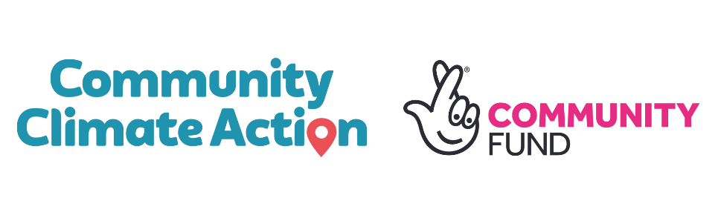
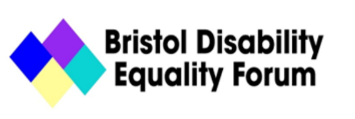

Job Description – Transport Champion

Work hours 21 hours a week fixed term for 2 years.
Salary range: £22,850.00 pro rata
Deadline: February 10th 2023
It is an ‘occupational requirement’ (a necessary part of the job), as defined and allowed under the Equality Act 2010, that the successful post-holder must be a Disabled person. It is also a requirement of our constitution that you are committed to the Social Model of Disability.

Purpose of the Job
The Transport Champion role is a new post. You will be part of the Bristol Disability Equality Forum Community Climate Action project team. This team will work to put into action the aims co-produced through our Community Climate Action Plan made by and for Disabled people. This plan has been made to propose how Bristol can meet its 2030 climate change targets in a way that is good for the planet and Disabled people.
The purpose of the role is to make sustainable (good for the planet) transport [and the plans for achieving it] in the city good for Disabled people. This role is funded by the National Lottery Community Fund’s Climate Action Fund.

Key Outcomes and Activities
- Run outreach events and communication campaigns to encourage to stop doing things that make transport [including walking/rolling] inaccessible for Disabled people.
- Talk to the public, businesses, and councils to get them to support our transport aims.
- Work with public transport service providers to influence policy and provide accessibility training for staff.
- Work with councils and researchers to work out how Disabled people who have to drive can do so in ways that are good for the planet.
- Gather case studies of ableist and disablist activity by public transport staff so that these can be used to push for change.
- Add to the transport work of the wider Bristol Community Climate Action Project. This includes supporting a Transport Vision, making a Sustrans Toolkit, and working with BGCP on the wider communication, evaluation, dissemination activity/aims of the project.
- Work in line with the project’s ways of working. See the Ways of Working document.

About the Community Climate Action Project
The Community Climate Action project has supported six disadvantaged communities in Bristol (Ambition Lawrence Weston, Ashley Community Housing, The Bristol Disability Equality Forum, Lockleaze Neighbourhood Trust, Eastside Community Trust and Heart of BS13) to co-produce their own community climate action plans with their communities. The project is co-ordinated by the Bristol Green Capital Partnership, and in partnership with Bristol City Council and the Centre for Sustainable Energy.
Phase Two of the project is about bringing the most important parts of those plans to life. Each community has their own project as part of this and a transport project is shared across all the communities. The National Lottery Climate Action Fund has given the project a large grant to make this possible. You can read more here.

About Bristol Disability Equality Forum
Charity no: 1146576
Address: 94 Grosvenor Road, St Pauls, Bristol, BS2 8XJ
Website: bristoldef.org.uk/

We believe that what limits Disabled people’s lives most are the attitudes of others, the way society is organised and the built environment (buildings, streets, etc). This is called the Social Model of Disability.

