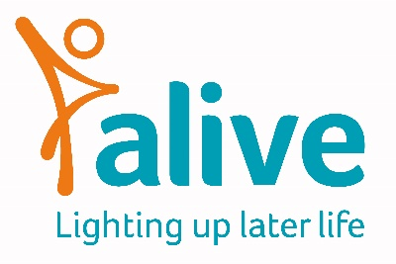

Job Title: Meeting Centre Manager

Salary: £25000 FTE
Post: 0.6 (3 days a week, 22.5 hours) 12 month initial contract
Overall Job Purpose:
To be responsible for the day to day running and overseeing of the Bristol Meeting Centre. To manage staff and volunteers within the Meeting Centre.
Main tasks and responsibilities
- Providing structure and leadership in daily activities for members of the Meeting Centre
- Maintaining an adequate staff team appropriate to contract requirements and client/staff ratios
- Responsibility for the recruitment, supervision, appraisal, induction, development and performance management of staff and volunteers working within the Meeting Centre
- Responsibility for managing the service-related budget
- Drawing up an individual support plan and appropriate risk assessments for venues, settings, members and family members
- Organising the group programme of activities and interventions
- Evaluating the impact and outcomes of the Meeting Centre
- Leading the discussion group for family members
- Organising community meetings
- Overseeing the opportunities for members to have individual and couples consultations
- Providing guidance regarding individual problems for couples and if necessary referring them to other support organisations
- Evaluating the support plans
- Maintaining contact with referrers
- Liaising with the host community centre or other organisation as appropriate
- Supplying Alive’s marketing team with relevant social media content

Additional responsibilities:
- To comply with data protection regulations, ensuring that information about members remains confidential
- To be responsible for learning and development for self and for those managed by this post
- To work collaboratively with the Meeting Centre Advisory Group fundraising and media and campaigns, sharing responsibility for the achievement of jointly agreed objectives as appropriate.

Person Specification

Skills and Experience

- NVQ level 3 in health and social care or equivalent
- Personal or work experience in a care environment
- An understanding of dementia
- Experience of managing and working with staff and volunteers
- Organisational and administrative skills
- Excellent record-keeping skills
- Computer literate, including using Office (365) suite

Attributes

- Able to assess and evaluate client needs
- Able to travel independently within the service area
- Empathy and compassion
- Non-judgemental communication
- Good team motivator
- Able to act as a representative of the Meeting Centre externally
- Commitment to and understanding of equal opportunities
- Understanding of the inclusion agenda and its relevance within a diverse society
- Ability to establish good working relationships with staff, service users and volunteers
- Ability to work independently, proactively and under own initiative
- Friendly and approachable
- Ability to be flexible and make the best use of available resources

Terms and Conditions of employment

Salary: £25,000 p.a. (pro rata) plus, contributory pension. Salaries are paid monthly in arrears and reviewed annually.

Closing date: Applications on the Alive application form by Monday 16th August at 12pm, and interviews will be held on Thursday 19th August. Please email applications to info@aliveactivites.org

Conditions of employment: This post is for 3 days a week (0.6) – 22.5 hours a week – days will be dictated by venue availability. Hours can be worked flexibly provided they are between Alive’s core working hours of 9 – 5. Alive staff work a 7.5-hour day. Annual holiday allowance is 25 days (pro rata) plus Bank Holidays. This is for a 12 month contact.

Location: Alive is based at the Create Centre, Smeaton Road, Bristol BS1 6XN. You will work remotely a the Meeting Centre venues.

Training: You will be encouraged to attend some Alive sessions and training. You will also attend the Meeting Centre UK Support Group and attend any training run by the national body.
Please note: This job description is for guidance. Employees are expected to be flexible and co-operative and to undertake additional duties as required.

