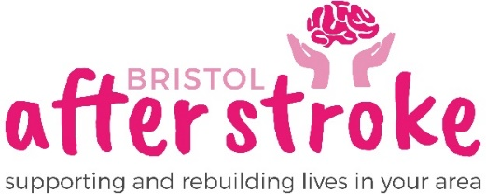

Counsellor (Part-Time, Home-based)
Role Description
£33,000 FTE (pro rata for 10 hours per week)

BAS offers short-term counselling to people who have had a stroke to help them adjust to what has happened and their life after stroke.
You will report to and work closely with the Lead Counsellor (who manages the counselling service and the wider emotional support offer). Your hours will need to overlap with theirs – they work Tues, Wed, Thurs from 9am to 5pm.
Location
You will be home-based and travel within the Bristol and South Glos areas to undertake counselling in people’s homes. A car driver is required for this post. You may also need to travel to some meetings.
Purpose of Role
- To provide 1:1 counselling (mainly in clients homes, sometimes online)
- To support the Lead Counsellor in the day-to-day running of the service.

Main Responsibilities - essential
- undertake assessments and provide one-to-one counselling
- keep records in line with BAS requirements and professional guidance
- undertake clinical supervision (up to 1 hour per month within BAS time)
- maintain confidentiality within the context of team working at BAS
- attend training and associated updates relevant to the role
- contribute to the continuous improvement of the counselling service.

Additional Responsibilities - on occasion, the post holder will…
- co-facilitate the ‘ACTion After Stroke’ course
- facilitate short online Mindfulness sessions
- deputise for the Lead Counsellor in their absence
- any other duties that may be reasonably requested.
Qualification & Experience
Essential
- A strong person-centred element of core training or a separate person-centred qualification, alongside an alignment to the humanistic approach
- BACP, UKCP accredited (or equivalent status with another professional body) or at least 450 hours’ counselling over a minimum of 3 years’ post-qualifying experience and on the PSA (Public Standards Authority) Register
- Competence to deliver online counselling (phone or video), if requested
- Commitment to and evidence of personal and professional development
- Experience of working in a short-term way, for example 6-8 sessions
- Knowledge and experience of safeguarding in a counselling context
Desirable
- Experience in an agency with awareness of GDPR and confidentiality
- Work experience with stroke-affected people or acquired brain injury
- Qualified or experienced in the use of creative methods in therapy
- Knowledge of or personal/professional experience in mindfulness
- Awareness of the stroke pathway and services

Skills & Abilities
- Ability to assess suitability for counselling and identify associated risks
- Ability to navigate complex ethical decisions within an agency setting
- Good interpersonal skills and ability to build therapeutic relationships
- Good standard of written and verbal communication skills
- Good time-management and diary management skills
- Basic proficiency with IT and video (Zoom and MS Teams)

Personal Qualities
- Patience to deal with distressed people
- Emotional resilience to meet people’s trauma stories
- Flexible and adaptable approach to work and own caseload
- Openness to working collaboratively with staff and volunteers
- Innovative and enthusiastic, bringing fresh ideas to the service

Other Essentials
Access to a personal computer and your own transport. You will be asked to complete an enhanced DBS disclosure and provide two references (one of which should be from your current or latest clinical supervisor).

