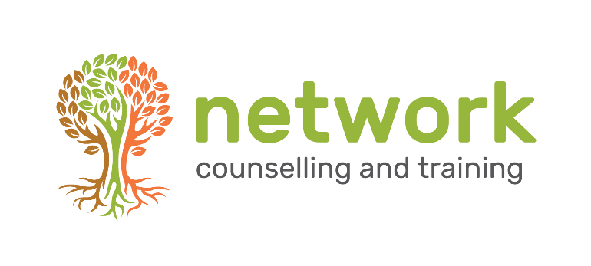

Being a Trustee with Network Counselling and Training.
THE TIME COMMITMENT
- we are asking people to commit 3 years to Network. If you are able to do more than this, that’s fantastic, and if you have to resign before 3 years are up, naturally, that would be fine.
- the "usual" time commitment is:
- an evening 2-hour meeting 4 times a year - February, May, late August/early September, early November, AND,
- attendance at the evening AGM, usually the 3rd week in January AND,
- 2 half days during working hours to plan strategy etc.
- occasionally, the Trustees meet more often if there are pressing issues. From May – December 2022, the Trustees and management team met once a month. In 2023, meeting frequency reverted to quarterly meetings.
- in addition, individual Trustees voluntarily take on tasks. The Chair and the Treasurer already have defined roles and duties. Individual Trustees choose to take on tasks and areas of interest dependant on their skills and expertise. New Trustees are generally not expected to take on such responsibilities during the first year.
- finally, one or two Trustees are required at intervals for senior staff interviews. This is an infrequent event – the last such interview was in Feb 2022.

OTHER INFORMATION
Discussion papers are usually not very long or dense. The hardest task is examining accounts and budgetary excel spreadsheets.
The senior management team are included in Trustee meetings. Decision making and responsibility for decisions lies with the Trustees, but the Board is better informed to make decisions if all the people who have the information are present.
Financial renumeration for travel is possible if requested. There is the possibility of joining meetings on zoom once in a while, but it would be best to attend several meetings in person to get familiar with the other folk before using that option.

