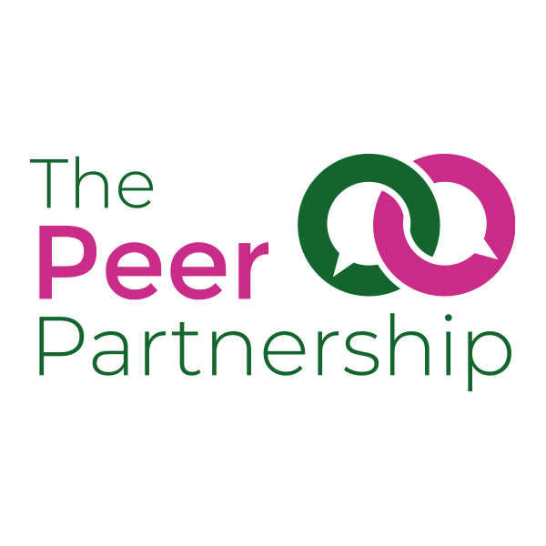
Peer Advocate Application Form

The Peer Partnership provides peer support for people living with long-term physical and mental health problems
Our volunteers are valued and respected for the time and effort they give towards maintaining and enhancing our services. As a volunteer in the Co-Creation Service you will have the chance to use your existing skills and hopefully gain some new ones.

Becoming a Peer Advocate involves:
- Completing the enclosed application form
- Providing Two references
- A short interview with The Peer Partnership Coordinator
- Attending the Peer Support training course

The induction course runs over three full days and one evening session. It will cover topics such as: your role and rights as a The Peer Partnership volunteer, basic peer support information, confidentiality, and an outline of the Co-Creation Service. The course is designed to make use of your own knowledge, skills, and experience. It aims to prepare you for the tasks and any challenges you might encounter while you are volunteering.

Once you become a volunteer

Volunteers will receive reasonable out of pocket expenses including mileage allowance or bus fare. You will also receive ongoing supervision to support you in your role.

IMPORTANT!
Please refer to these notes before completing the application form

1. Help with completing the form

If you need help in completing the form for any reason at all, please contact The Peer Partnership. This will not go against you when you apply.

2. What we look for in a volunteer

Please use this list to help you understand what will be looked for in your application form, as it is through this form that the selection for the interview will be made.

- An understanding of and commitment to the aims and objectives of our peer mentoring services
- A positive attitude to people living with long term conditions
- The ability to communicate with staff, other volunteers and clients
- A non-judgmental approach to those who have different background to your own
- Openness and willingness to address difficult issues
- The ability to work as part of a team
- Willingness to positively engage in your own supervision
- Patience
- Reliability

This list of qualities that The Peer Partnership looks for in a volunteer has been designed to help you understand what we need, and to help decisions to be made in line with equal opportunities. No formal qualifications are required, and training will be provided

All these requirements will be explored during the training course.

3. The application process

When you return your form, The Peer Partnership Coordinator will assess it. If your application meets our standards you will be invited to an interview. If we consider that you are suitable for the role you will be given a place on the volunteer training and sent details before the program starts. Please note, being offered a place on the training does not guarantee you to be an advocate. The training program will also be an opportunity to assess your suitability to be an advocate.

If you have any questions about the role or application process, please get in contact with:

Sean Hourigan
The Peer Partnership Coordinator

The Peer Partnership
Easton Community Centre
Kilburn Street
Easton
Bristol
BS5 6AW

0117 9555 038

seanhourigan@PeerPartnership.org

Peer Advocate Application
Thank you for your interest in volunteering with The Peer Partnership. This form is an opportunity for you to give us some information about yourself. It forms part of our volunteer selection process.
Please complete it as fully as you can, using the attached information to help you. Do not hesitate to contact us if you need any assistance in filling out this form.
Personal Details:

Name: Click or tap here to enter text.
Address: Click or tap here to enter text.
Date of Birth: Click or tap to enter a date.
Tel: Click or tap here to enter text.
Email: Click or tap here to enter text.

Is it ok to leave you a voicemail? Yes ☐ No ☐

Is it ok to text you? Yes ☐ No ☐

- Why are you interested in becoming a peer advocate with The Peer Partnership?

Click or tap here to enter text.

- What skills, qualities, and/or experience (paid or unpaid) can you offer the role of Peer Advocate? (please refer to the role decription)

Click or tap here to enter text.

- The Peer Partnership works with people from a wide variety of backgrounds in terms of sexuality, drug use, ethnicity, employment etc. How do you feel about working with people who may have very different life experiences from your own?

Click or tap here to enter text.

- What condition would you like to propose for a peer support program?

Click or tap here to enter text.

- Do you live with, or are you affected by this condition personally?
(by affected by, we mean that you may be acting in the role of carer for a person who is living with the condition)

Live with condition ☐ Affected by condition ☐

How are you affected?

Click or tap here to enter text.

- What do you see as the problems faced by people living with this condition?

Click or tap here to enter text.

- How do you feel a peer support program would help to improve the experiences of people living with the condition?

Click or tap here to enter text.

- Do you want to create this program for everyone living with this condition, or do you feel you would like to focus on a specific group (such as gender, ethnicity, students, over 50s etc) who are affected?

Everyone ☐ Specific Group ☐

- If you answered a specific group to the previous question, please provide further details of the group and reasons for your answer.

Click or tap here to enter text.

Declaration and DBS checks

Do you have any convictions, cautions, reprimands or final warnings that are not “protected” as defined by the Rehabilitation of Offenders Act 1974 (Exemptions) Order 1975 (as amended in 2013)?

This information is treated as confidential

Tick as appropriate Yes ☐ No ☐
Please use this space to give dates and information
Click or tap here to enter text.
Please note this role will involve working with vulnerable people and so we will carry out a DBS (Disclosure and Barring Service, formerly Criminal Record Bureau) check.

Having a criminal record will not necessarily prevent you from mentoring with The Peer Partnership

References

Please provide the names and addresses of two people who can comment on your suitability for volunteering with us. References will be contacted before the interview due to time restrictions.

Please note the references cannot be a partner or family member. They could be a volunteer manager, trainer, tutor, medical practitioner etc.

Please also note the references need to know your health condition status – this is due to when we contact them we will be mentioning The Peer Partnership and that it is a Peer Support role.

Name: Click or tap here to enter text.
Address: Click or tap here to enter text.

Tel: Click or tap here to enter text.
Email: Click or tap here to enter text.
How do you know this person: Click or tap here to enter text.
Name: Click or tap here to enter text.
Address: Click or tap here to enter text.

Tel: Click or tap here to enter text.
Email: Click or tap here to enter text.
How do you know this person: Click or tap here to enter text.
Your contact details will be held on computer and this application form will be securely filed. All personal details held are secure and strictly confidential to Brigstowe. We will use the information for contacting you and for monitoring our volunteering base.
Please sign below to give your consent to us keeping this information on our records

Interview

We will be holding interviews throughout February and March 2021. We can offer a choice of face-to-face or telephone interviews. Interviews will be around 45 minutes. Please answer the following questions to help us provide the most appropriate interview situation for you:

Would you prefer to have a face-to-face or telephone interview?
(this will also depend on current government guidance around meeting in person due to COVID19)

Face-to-face ☐ Online Video ☐ Telephone ☐

Are there any dates when you will NOT be available for interview?

Click or tap here to enter text.

If you would prefer a face-to-face interview, do you have any specific accessibility needs to attend, for example wheelchair access:

Click or tap here to enter text.

Signature

Applicants signature: Please enter email if filling in electronically

Date: Click or tap to enter a date.

Please return to:
seanhourigan@PeerPartnership.org
The Peer Partnership, Easton Community Centre, Kilburn Street, Easton, Bristol, BS5 6AW
Equal Opportunities

The Peer Partnership aims to ensure that all applicants are treated fairly and are not discriminated against, either directly or indirectly, on grounds of ethnic origin, gender, disability, sexuality, age or religion. We will try to gather information from applicants to check that we are not discriminatory in who we shortlist and select. The information provided will only be used for statistical purposes.

Please return this form with your application. The form will not be looked at until after the recruitment process is finished and will have no bearing on your application for this role. If you prefer, please send separately to your application form.

How did you find out about this post?

☐ The Peer Partnership website
☐ Word of Mouth
☐ Social media (please state): Click or tap here to enter text.
☐ Other (please state): Click or tap here to enter text.

Demographic Information
GENDER | Male  ☐ |  | Female  ☐ |  |  |  | Prefer not to say  ☐ |  |  |  |  |  | Is this the gender you were assigned at Birth?  Y☐/ N☐
ETHNICITY | White British ☐ |  |  |  |  | White Irish ☐ |  |  |  |  | White Gypsy / Traveller ☐ |  |  |  | White Any Other ☐
Black / Black British ☐ | Caribbean ☐ |  |  |  |  | African ☐ |  |  |  |  | Asian ☐ |  |  |  | Chinese ☐
 | Mixed White Asian ☐ |  |  |  |  | Mixed White Black African ☐ |  |  |  | Mixed Any Other ☐ |  |  |  |  | Prefer not to say ☐
SEXUAL ORIENTATION | Heterosexual  ☐ |  |  |  | Bisexual  ☐ |  |  |  | Gay /  Lesbian  ☐ | Asexual / non-sexual ☐ |  |  |  |  | Prefer not to say ☐
RELIGION | Christian ☐ |  |  |  |  | Muslim ☐ |  |  |  | Jewish ☐ |  |  |  |  | Sikh ☐
Buddhist ☐ |  | Other Religion ☐ |  |  |  |  |  | No Religion ☐ |  |  |  |  |  | Prefer not to say ☐
DISABILITY | The Equality Act 2010 defines a disabled person as someone who has a physical or mental impairment which has a substantial and long-term adverse effect on their ability to carry out normal day-to-day activities.
Do you consider yourself to be disabled? | Disabled ☐ |  |  |  |  | Non-Disabled ☐ |  |  |  |  |  |  | Prefer not to say ☐
EMPLOYMENT | Employed FT / PT ☐ |  |  |  |  | Looking for work  ☐ |  |  |  |  |  | Not entitled to work ☐ |  |  |  | Long term sick / disabled ☐
Carer ☐ | Student ☐ |  |  |  |  | Parent ☐ |  |  |  |  |  | Retired ☐ |  |  |  | Self-Employed ☐
IMMIGRATION STATUS | British Citizen  ☐ |  |  |  |  | Indefinite LTR  ☐ |  |  |  |  |  | Discretionary LTR  ☐ |  |  |  | Awaiting Home Office decision ☐
Asylum Seeker ☐ | EEA ☐ |  |  | Visa – work / student / visitor / spouse ☐ |  |  |  |  |  |  |  | Refused Asylum Seeker ☐ |  |  |  | Overstayer  ☐

