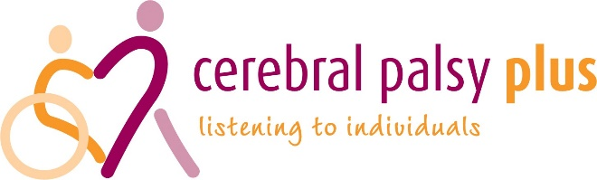

Cerebral Palsy Plus - Part time Volunteer & project Coordinator
Person Specification –
Essential Criteria-
Experience of:
Working closely with a network of volunteers and supporting them on a day-to-day basis.
Experience of co-ordinating volunteers.
Demonstrable leadership skills.
Working independently and being self-motivated.
Excellent communication skills.
Ability to work within a small team.
Ability to carry out research into service development
Developing a small project and responding flexibly to ideas.

Knowledge and understanding:
Diversity, Social Inclusion, equal opportunities, and anti-discriminatory practice re physical and attitudinal barriers

Skills & Abilities:
Be passionate about working with people.
Able to inspire other people.
Ability to work on own initiative.
Ability to keep calm under pressure.
Willingness to be hands on and flexible,
Can-do attitude within the team.

Desirable Criteria-
Experience of working in a small charity
Flexibility in role
Experience of working with people with additional needs

Other job-related requirements-
Enhanced DBS check renewed every 3 years
Able to work outside normal hours, as required
Ability to travel around the BS postcode area.

A good understanding of, and commitment to, the safeguarding of vulnerable adults and children

