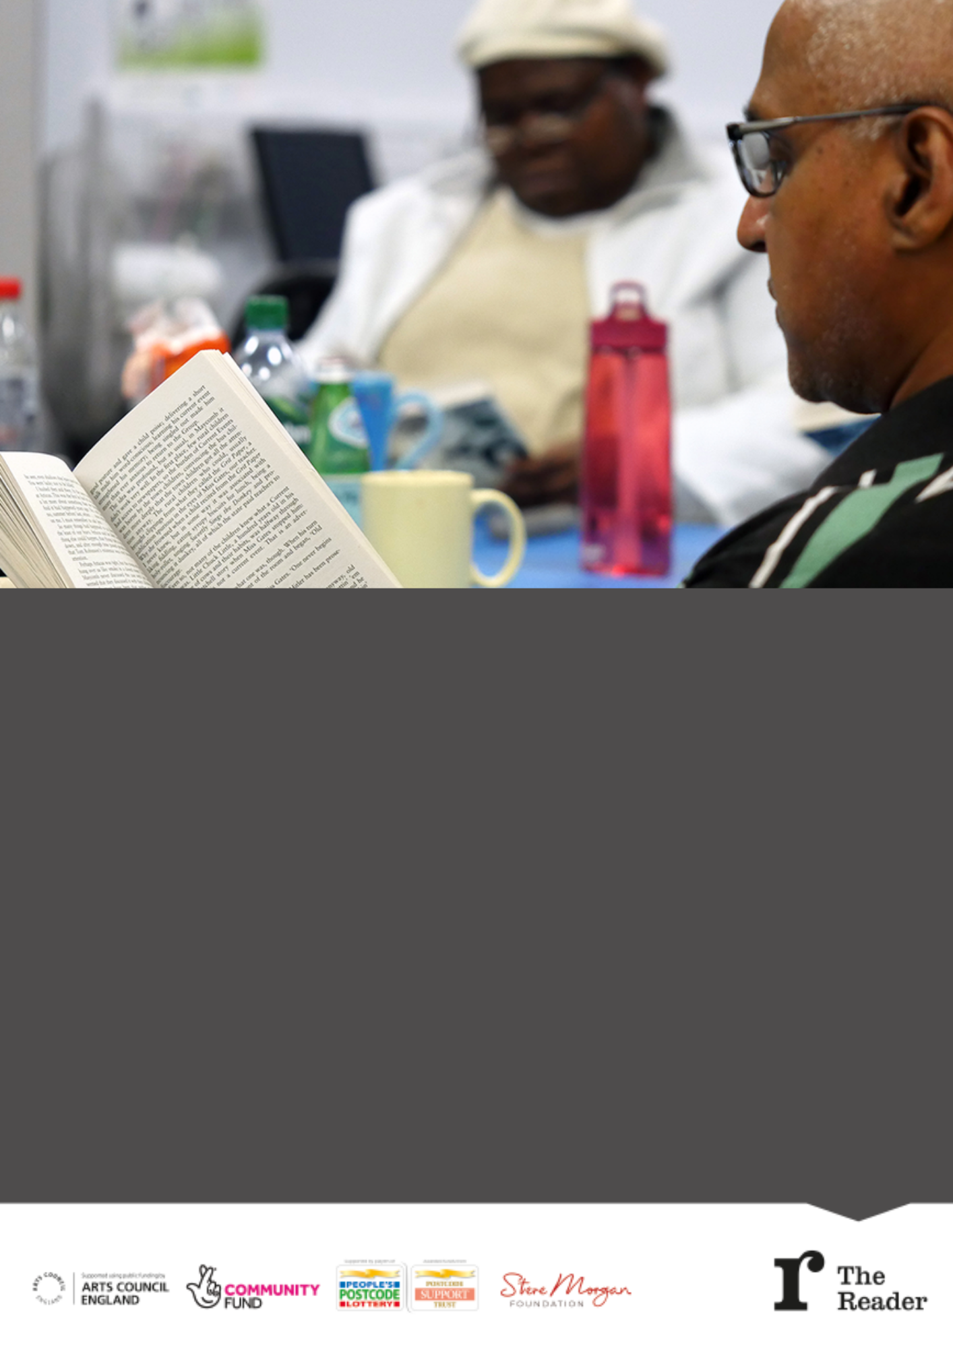

**MEET**PEOPLE

**SHARE** EXPERIENCES

**FEEL** CONNECTED

|  |  |  |  |
| --- | --- | --- | --- |
|  | | | |
| **Speak to us** 0151 729 2200 | **Email us**  info@thereader.org.uk | **Find out more online**  www.thereader.org.uk | **Connect with us**  *#SharedReading* |

Love books? Love people?

Shared Reading groups bring people together through great literature to talk, laugh and share.

We’re looking for volunteers to lead our groups in Bristol. We work in libraries, community centres, care homes and hospitals. Full training given.

**See website or contact**

**michaelprior@thereader.org.uk**

**for more information and to apply.**