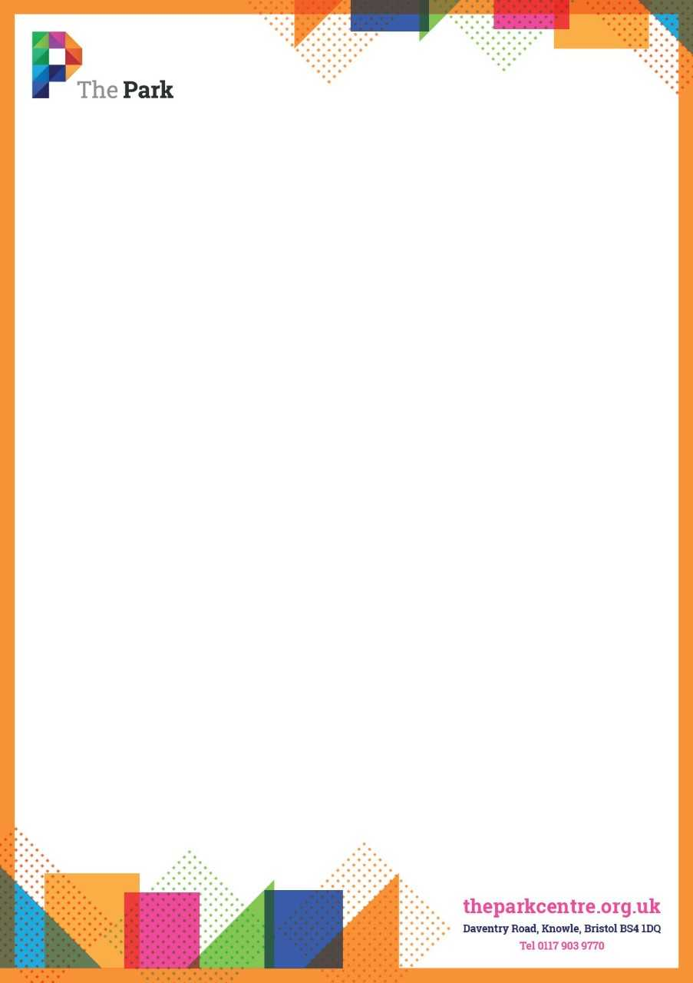

**Evening and Weekend Reception hours at The Park Community Centre**

We are recruiting for evening reception hours at The Park Community Ltd in Knowle.

The Park is a thriving community venue with a diverse customer base.

You will be very customer focused, confident, flexible, adaptable and ideally have some experience in alarming and locking up buildings.

We are looking for 3 people to cover shifts on a Monday-Friday evening.

Shifts start at 4pm or 5pm and finish at 10.30pm.

Position 1- 19.5hrs

Position 2- 11hrs

Position 3- 11hrs.

Salary- £9.70ph.

If you are interested in this fantastic opportunity, please contact Joy Pollard for an application pack on [joy.pollard@theparkcentre.org.uk](mailto:joy.pollard@theparkcentre.org.uk) or 0117 9039770.

Closing date Friday 8th July 2022.

Please return completed applications to Emma Hinton on [emma.hinton@theparkcentre.org.uk](mailto:emma.hinton@theparkcentre.org.uk)