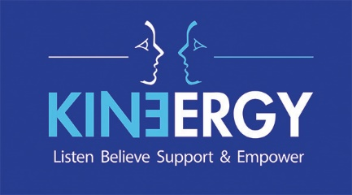

Receptionist/Administrator - Job Description

Responsible to: Director of Operations

Pay Rate: £9.50 per hour

Working Hours: 12 hours a week split over 2 days, including one evening.
Potential for hours to increase

Holiday Entitlement: 29.5 days a year plus Bank Holidays (pro rata)

Location Kinergy, Mary Carpenter House, Kingswood Foundation Estate, Britannia Road, Bristol, BS15 8DB

Probationary Period: 6 months

JOB SUMMARY:
To be the first point of contact at Kinergy for clients and anyone contacting the charity, to manage the reception function and provide administrative support.

Reception Duties:
- To welcome clients and other visitors in person or on the telephone.
- Manage the telephone, answer phone and email systems, and deal with messages accordingly.
- To deal with referrals to the services Kinergy offers.

Administrative Duties:
- Receive incoming post and emails and distribute as appropriate.
- Dispatch outgoing post.
- To make up client files and keep all paperwork stocked up and up to date.

Office Duties:
- Photocopying/emailing/scanning
- Maintain stationery supplies and appropriate leaflets in reception area and counselling rooms
- Word-processing
- Database input
- Arranging recycling of office waste paper goods

General Duties:
- Work as an effective and cooperative member of Kinergy’s team
- Attend Team Meetings when required
- Take minutes of meetings and circulate to attendees
- Adhere to Kinergy’s policies and procedures
- Assist with AGM preparations
- Assist Managers as required
- Any other duties on behalf of Kinergy, which the Director of Operations can reasonably and lawfully expect

Responsibilities may vary from time to time in line with any service delivery changes.

Receptionist/Administrator - Person Specification

Essential Criteria | Desirable Criteria
Experience  - At least one year’s experience (paid or unpaid) of working in a reception role  - Experience of working in an office environment  - Ability to communicate clearly and sensitively, by phone and in person, with people from different backgrounds  Skills and Knowledge  - A working knowledge of Microsoft Office and databases  - Excellent listening, written and verbal communication skills  - Excellent customer service skills and telephone manner  - Ability to work in a team and support other staff and volunteers  - Ability to work independently and use own initiative  - Ability to manage time effectively, to prioritise tasks and work to deadlines  - Ability to work accurately and methodically within defined systems  - Ability to liaise with external organisations  - Knowledge of and a commitment to health and safety, equal opportunities and confidentiality policies and procedures | - Experience of working in a community-based, client-centred or voluntary sector organisation.  - Experience or training in dealing with difficult situations.  - Knowledge of social media, PR and website design  - Knowledge of the impact of sexual abuse and assault on survivors  - Understanding of counselling and therapeutic spaces

