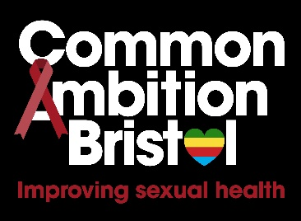

Community Member for Project Delivery Group
Role Description

Position: Community Member
Time Commitment: Approx. 4 hours per month (& sometimes more on occasion)
Start Date: July 2023 -
Must be available for:
- Thursday 13th July 5pm-8pm upstairs at the Greenbank Pub BS5 6DP
- Thursday 14th September 5pm-8pm upstairs at the Greenbank Pub BS5 6DP
- Friday 6th October 9.30-12.30pm Barton Hill Settlement BS5 0AX
- Thursday 12th October 5pm-8pm upstairs at the Greenbank Pub BS5 6DP
*Future dates and venue for November and onwards are still to be confirmed

Commitment: around 4 hours a month until 31st March 2025

Skills and Experience:
- To be part of and have good links with the African and/or Caribbean communities in Bristol
- To be able to think creatively
- Good analytical skills (i.e. analyse information, problem solve & make decisions)
- Good time management & organisational skills
- Good IT Skills (confident in using MS Word, email & Zoom) with the equipment for taking part in meetings at home
- Able and willing to discuss HIV and sexual health
- A passion for working with communities particularly in relation to health and inequality
- Good communication skills (i.e. listening and speaking)
- Respect for diversity
Training & Support Provided:
- Full training and induction
- Regular communication and support
Transferable skills and experience gained from participating:
- Experience of contributing & implementing change within your community
- An opportunity to support good sexual health & wellbeing in your community
- Experience of working with collaborative partners
- Experience of taking part in research and evaluation
- Increased confidence in communication and presentation skills

As well as being paid for taking on this role you will also receive reimbursement for out-of-pocket expenses up to a reasonable amount.

