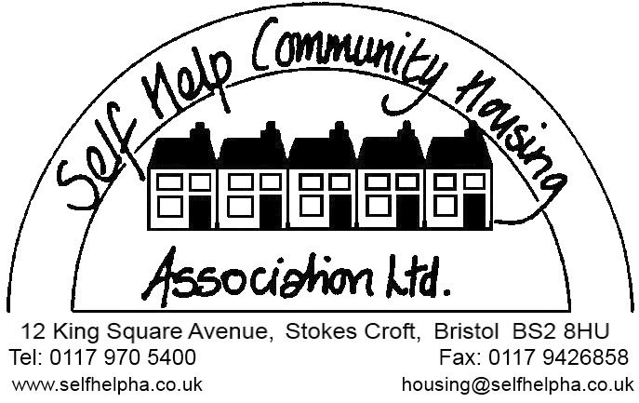

We offer homeless people the chance of a future through housing, support and advice. We provide a high quality service to homeless people and help them to overcome the issues that led to their homelessness

This approach is found in our values

• Everyone should have the opportunity to make the transition from homelessness to a sustainable home.
• There should be equal opportunities for our diverse mix of clients and staff.
• Our staff will act with respect, integrity and openness.
• Our staff will be creative, innovative and inspiring.
• We will focus on outcomes, efficiency, excellent performance and continuous improvement.
• We will listen, involve, and deliver on needs.
• We will understand the background of our clients and make changes to our services to accommodate these differing backgrounds.
Who are we?
We have been operating for over 40 years in central Bristol and work with people with a range of support needs which can include substance abuse, mental health, physical health, criminal offending, debt and money management.
What do we provide?
We provide over 60 units in the Single Men’s Pathway at Level 4 (low support) and we are the final step before independence.
We provide dispersed, fully furnished, shared accommodation throughout central parts of the city, including areas of Easton, St Pauls, Bedminster, Windmill Hill and St Werburghs.
Who works for us?
We employ resilient individuals looking to make a difference to people’s lives. Our organisation is based within central Bristol at our offices in Stokes Croft with staff based there and working within the community. Staff members take part in regular Reflective Practise as a group and have regular supervision.
We are a small but hugely supportive team who regular make a large impact on the lives of our service users to sustain and move into long term accommodation through commitment, collaboration and perseverance.
Any questions?
Contact our Operations Director Aaron Minnigin
Email: aaron@selfhelpha.co.uk Telephone: 0117 9705400
Terms and Conditions:
Contract type: Permanent
Contracted hours: 35 hours per week within a flexible working pattern (Monday to Friday)
Starting salary; £19100
Rising to £20100 on completion of probation then up to £22000.
Location: Office & Community based
Responsible to: Support Services Manager
Disclosure Barring Service (DBS) Check: We safeguard and promote the safety and welfare of children, young people and vulnerable adults. Any job offer will depend on a satisfactory DBS (Disclosure and Barring Service) Barred List Disclosure Check. Due to the type of position this will be an enhanced check.
Annual leave: 21 days, plus all public and bank holidays. This will be pro rata according to your start date in the Annual leave year. Increasing from the holiday year following 2 years continuous service.
Equal Opportunities
The Association is an equal opportunities employer. It is the Association's policy to treat all employees and job applicants fairly and equally regardless of their sex, sexual orientation, marital status, race, colour, nationality, ethnic or national origin, religion, age, disability or union membership status.
Company sick pay:
Criteria | Current Entitlement
During the Probationary Period | 10 days full pay then SSP Only
Up to 12 months Service | One Month’s Full Pay and 6 Weeks Half Pay
12 to 24 Months service | Two Month’s Full Pay and 6 Weeks Half Pay
In excess of 24 months service | Three months full pay and 6 Weeks Half Pay

Pension Scheme: We operate a pension scheme with 4% employee contribution and 2.5% employer contribution
Life Insurance: 3 times annual salary cover to all part of the Pension Scheme
Notice period: During probationary period: One week. After confirmation of appointment: Four weeks.

