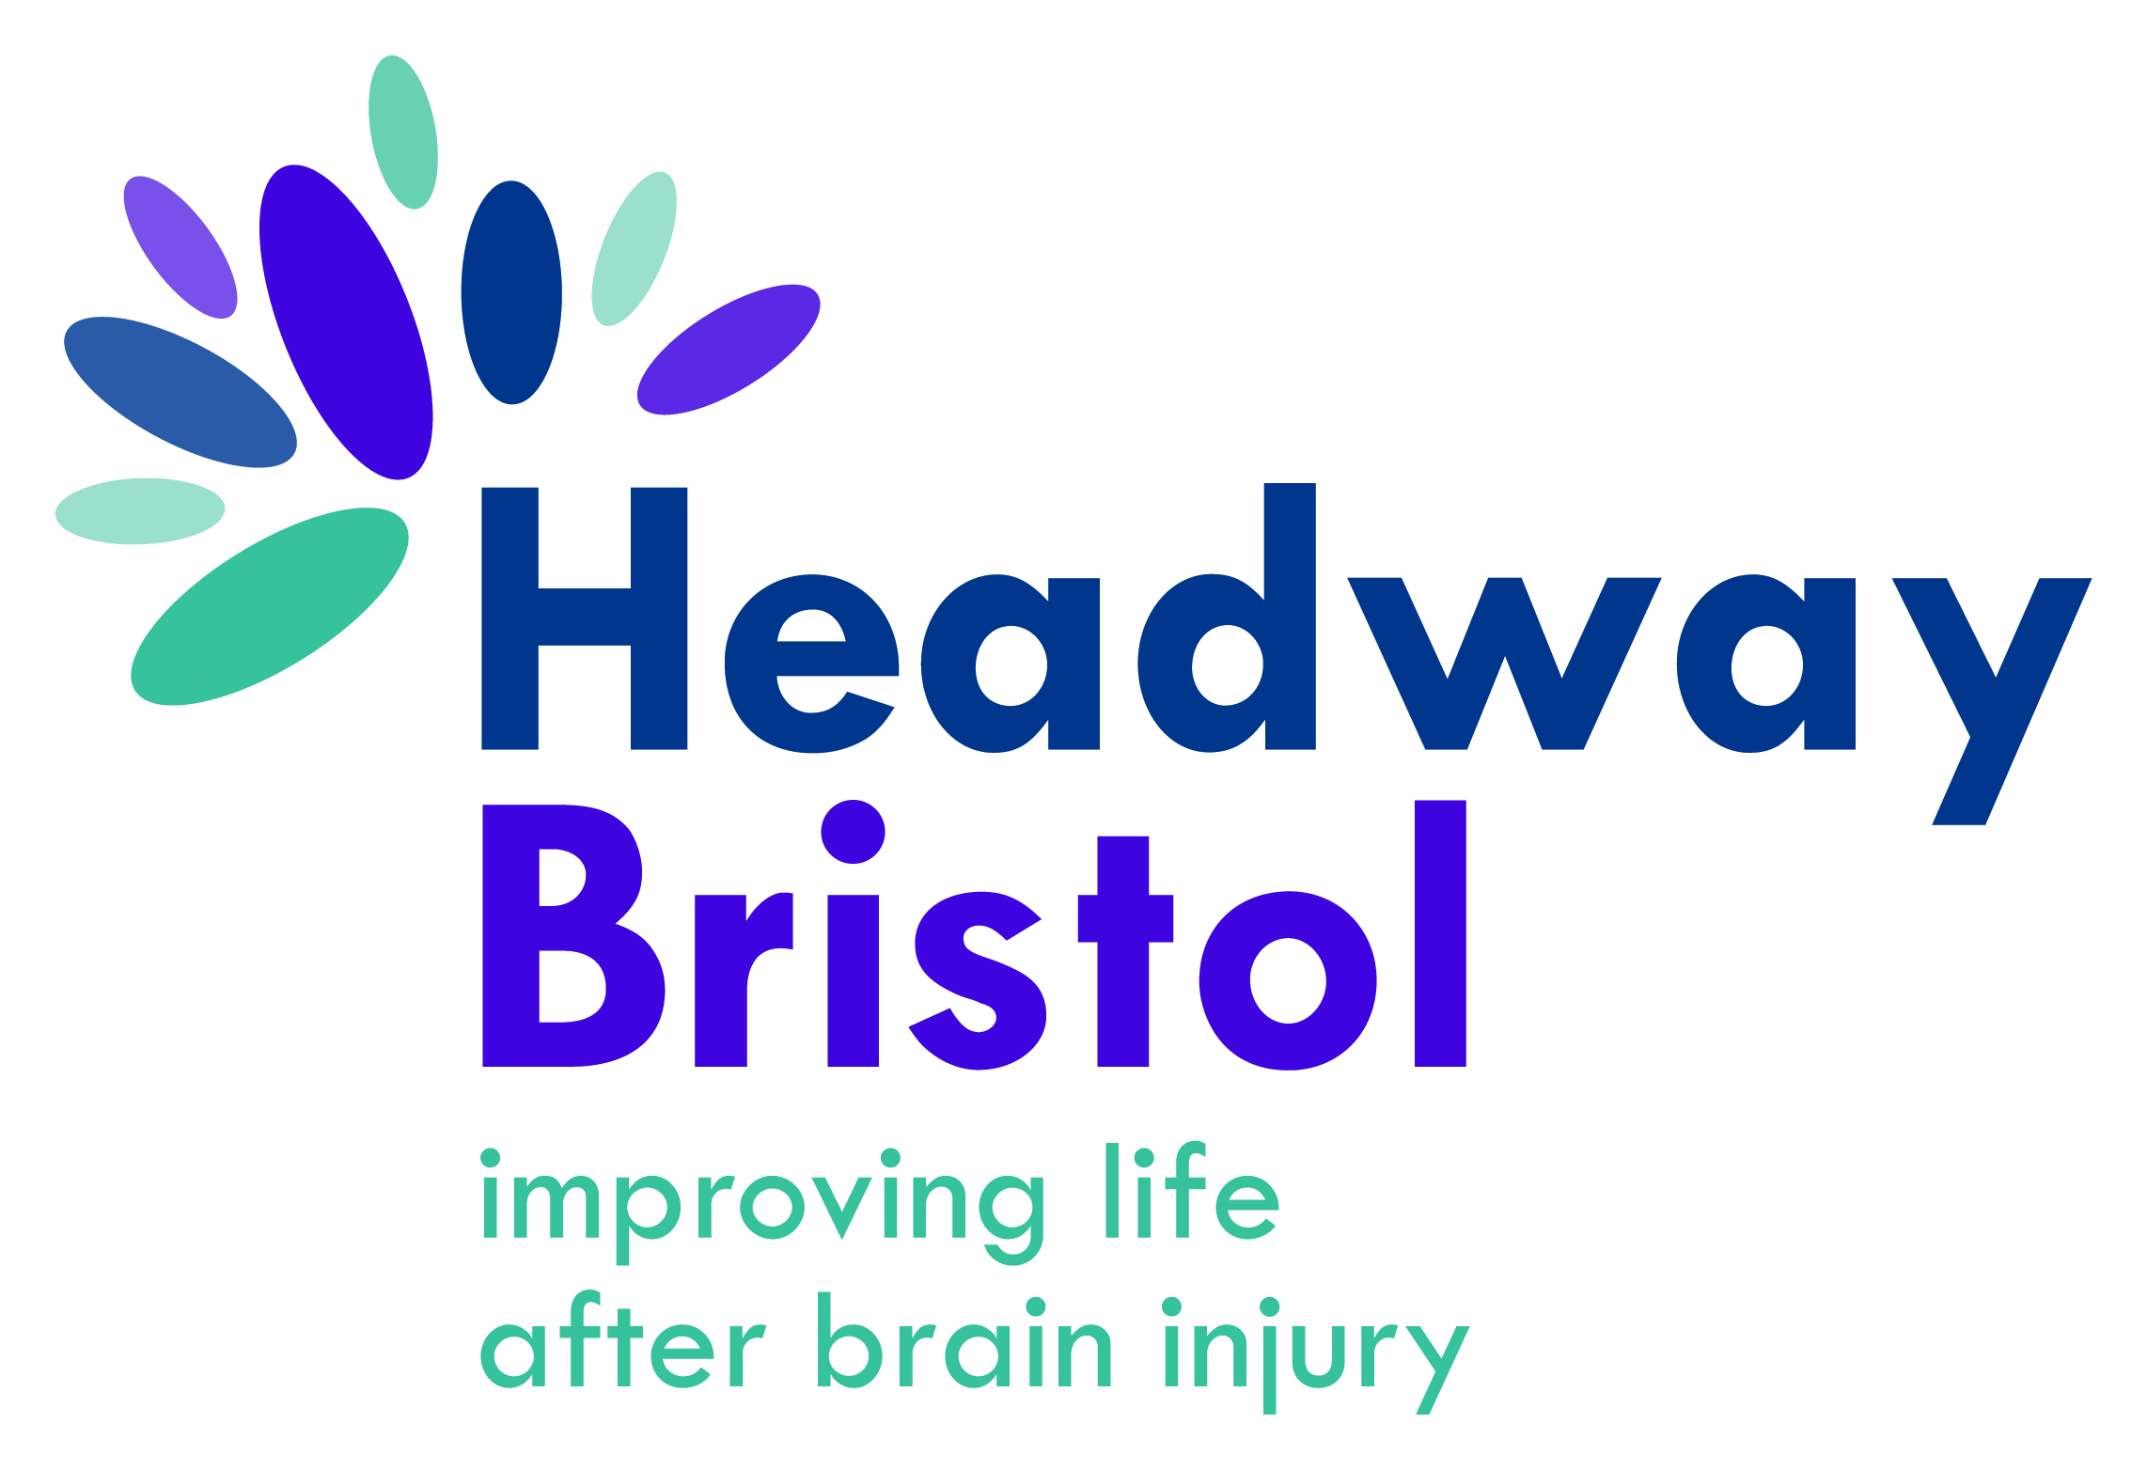
SUPPORT OUTREACH WORKER
SPECIALIST BRAIN INJURY CHARITY

“It's nice to support someone to have the quality of life they deserve” - Lindsey, Support Outreach Worker, Headway Bristol

With a 42 year history behind us in Bristol, we are proud of our roots and achievements, supporting brain injured survivors and their families and carers across the region.

Our services include a Rehabilitation & Wellbeing Centre in Frenchay, Carers and Hospital service and Community Outreach service. A vacancy now exists within our Outreach team as we respond to an increased demand in our services.

As part of our dedicated Outreach Services team, your role will involve supporting our adult service users in their homes or out and about in the community; working with them to help develop their social and cognitive skills as part of their rehabilitation programme. Your care industry training and experience will be put to good use, helping individuals regain their confidence, learn new skills and redevelop old ones. We are looking for caring, friendly and reliable individuals who are able to work independently with individuals on a one to one basis, but also flexibility as part of the overall outreach services team.
Our Outreach Workers need to demonstrate initiative, enthusiasm, flexibility and excellent time keeping. Some personal care maybe involved in accordance with individual care plans but your primary focus will be to support individuals with completing everyday tasks that most of us take for granted - from doing the shopping, cooking and housework, to getting on the bus to the local library or leisure centre.
An awareness and/or understsanding of the sensory, cognitive and physical disability of a person who has sustained a brain injury or other similar condition such as stroke, dementia or mental health would be a distinct advantage. The role can often be challenging and you will have the maturity and experience to be able to support those who have complex needs and behaviour problems.
Our core services are delivered across a wide range including Bristol, Bath, South Gloucestershire, Wiltshire and North/North East Somerset. A full driving license, motor insurance and use of own car is essential for this role.
Qualifications: You will ideally have an NVQ2 in Health & Social Care, a similar qualification and/or an appropriate level of experience). The post is subject to a DBS check and satisfactory references.
Salary & Benefits: Hourly rate commences at £10.10 per hour (£18,400 pa). We offer 25 days annual leave plus bank holidays where part time, time off in lieu, free parking and a stakeholder pension. Our staff training and development programme, which includes training in understanding brain injury and cognitive rehabilitation therapy (CRT), will ensure that you remain up to date on all your key skills and experience. You will be equipped with a personal laptop to keep you in touch with the team and receive regular supervisions and annual development reviews.
Hours: Our core services are delivered Monday to Friday 9.00am-5.00pm – although some flexibility is essential as there is a requirement to occasionally work an odd evening or weekend (these will be agreed with you in advance). This post is offered on a full time basis, 35 hours a week and also a 28hr post both roles working from Monday to Friday. Please state your preferred hours in your application.
Unfortunately, due to our strict Equal Opportunities monitoring we do not accept CV’s. Interested applicants will need to complete an Application Pack as below. Alternatively, you can request an Application Pack either by emailing us at vacancies@headwaybristol.org.uk or by telephoning the office on 0117 4143222. If you would like further information about the role before applying, please don’t hesitate to contact our Services Manager on the same number.
Please ensure that your application is received by the deadline date and time below and if you are unable to attend an interview on the date below, if short listed, please do let us know when applying.
Headway Bristol is an Equal Opportunities employer and welcomes applicants from all sections of the community. All offers of employment are subject to satisfactory references and DBS check.

Application deadline- Monday 12th October by 9am

Interviews to commence week of 19th October 2020

