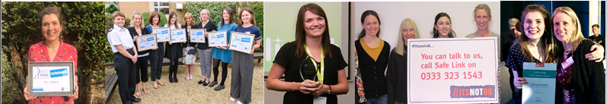
LGBTQ+ Independent Sexual Violence Advisor (ISVA)
Award Winning Service Safe Link

Would you like to work for an award winning service by providing specialist sexual violence support to victims from the LGBTQ+ community who live across Avon and Somerset?

We have a rewarding and exciting opportunity available for a LGBTQ+ Independent Sexual Violence Advisor to join our team based in Bristol (with requirement to travel across Avon and Somerset). You will join us on a full-time, permanent contract working 37.5 hours each week on a rota basis (8.30am–4.30pm & 9.30am–5.30pm also occasional Saturday morning on a rota (around 1 in 12) and to be available to work until 8 pm if required); you will provide support and advocacy to victims who have experienced rape or sexual assault. In return, you will receive a competitive salary of £27,852 per annum and benefits.

In return for joining us, we will offer you:

- Up to 30 days annual leave (depending on length of service)
- 3 extra holidays including International Women’s Day
- Excellent development and training opportunities
- Employer pension contribution (minimum 5% of your gross salary)
- Mindful Employer Plus Scheme
- Cycle to Work Scheme
- Long Service Awards
- Wellness Awards

SAFE Link was established in 2009 and is a service that works across the Avon and Somerset Police Area and provides emotional and practical support to victims of rape and sexual assault. SAFE Link provides an independent victim-focused service. The service is committed to the Victims Code of Practice. Our ethos is to enable victims to cope and recover after their assault. We can support victims to report to the police if they wish.

Our Independent Sexual Violence Advisor will work closely with the Bridge (SARC), CYPS, Police, CPS, safeguarding and both voluntary and statutory agencies including mental health and drug and alcohol agencies. You will have a good understanding of the traumatic impact of sexual assault and rape. You will need to have knowledge around the criminal justice process and will have a commitment to providing a high quality, victim focussed and inclusive service.
We are looking for a highly motivated individual to work as a LGBTQ+ ISVA within the integrated team. You will be supported to develop the skills, knowledge and competencies to contribute to and assist in the provision of ISVA support to LGBTQ+ victims and their families to cope and recover.

Key duties and responsibilities of the LGBTQ+ ISVA:

- Empathy with the needs of LGBTQ+ Communities victims of rape and sexual assault and the barriers they face
- An understanding of the impact of sexual violence and abuse on victims
- The ability to learn new skills and a commitment to learning in the workplace
- A commitment to participating in a training programme
- A current full driving licence and access to an appropriate vehicle is essential.

How to apply:

Please download the application pack from our website and complete the application form. Please submit your application by Friday 9th June 2023. Please do not send CVs. Interviews will be held on Thursday 15th June 2023.

www.safelinksupport.co.uk HR.Enquiries@missinglinkhousing.co.uk

SAFE Link is committed to safeguarding and promoting the welfare of children, young people and adults at risk of abuse, and expects all staff and volunteers to share this commitment. SAFE Link is committed to Equal Opportunities. *Due to the specific requirements of this role, this post is exempt under the Equality Act (2010), Part 1, Schedule 9 (Genuine Occupational Requirement.

