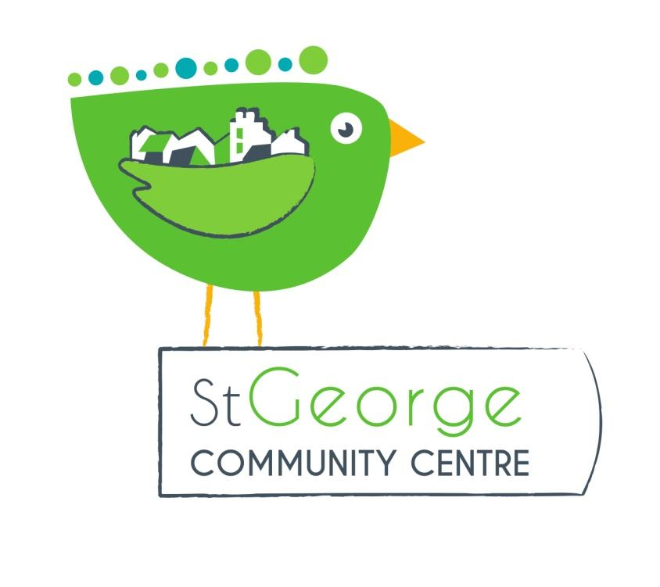

Role Title: Volunteer Secretary and Trustee St George Community Association (SGCA)

Purpose/summary of role
Support the chair by ensuring the Committee functions smoothly. The secretary may carry out their duties directly or delegate them and ensure that they have been carried out.

Tasks
In addition to the general responsibilities of a trustee, duties of the secretary are as follows.

Preparing agendas in consultation with the chair, and circulating them and any supporting papers in good time

Making all the arrangements for meetings (booking the room, arranging for equipment and refreshments, organising facilities for those with special needs, etc)

Receiving agenda items from other trustees/staff

Checking that a quorum is present

Taking minutes (or being responsible for them being taken) and circulating draft minutes to all trustees

Ensuring that the minutes are signed by the chair once they have been approved

Checking that trustees and staff have carried out actions agreed at a previous meeting

Circulating agendas and minutes of the annual general meeting and any special or extraordinary general meetings

Sitting on appraisal, recruitment and disciplinary panels as required

Person specification
In addition to the person specification for a trustee, the secretary should have the following qualities.

Organisational ability

Knowledge or experience of business and committee procedures

Minute-taking experience.

Time Commitment
We would expect the Secretary to commit to the role for a minimum of 12 months. We would expect that the secretary to attend regular committee meetings (currently monthly) and provide around an hour a week admin time.

Benefits to volunteer
This is a great opportunity to contribute to the work of St George Community Association if you have experience of, or are interested in running community groups . The secretary role is essential for making sure our organisation runs successfully and continues to provide an affordable community venue for local residents. As a trustee you will be helping to provide a resource for the wellbeing of the local community.

Application Procedure
Informal interview with the current Chair and other member of the committee as appropriate. We will also require satisfactory references.

Background Information
St George Community Association is a registered charity and not-for-profit company limited by guarantee. It was set up in 1987 by by a group of local residents who felt that there was a need for a community centre in St George. They originally met in a local library and held events in St George Park. After many years of campaigning a local building was found on the site of the old grammar school canteen. The building was in complete disrepair and eventually, in 1995, grant aid was given by Bristol City Council and the new Community Centre was built.

The organisation has a Community Asset Transfer from Bristol City Council, who lease us the building rent free. In return we look after and run the building for the benefit of residents in St George. This means that all hire income is used to maintain the centre and develop new community activities.

Our turnover is currently around £20,000 per annum with additional grant funding for events or improvements. The bulk of our income comes from our regular hirers, followed by weekend parties and special event bookings. We apply for small grants for specific projects e.g. replacing the flooring in the main hall, new signage. We raise a small amount from community events such as our Christmas Fair, Table Top sales, Family fun days etc.

Our volunteer committee of local residents runs the organisation. The Chair, Treasurer and Secretary also serve as Directors of our company limited by guarantee We have a paid manager for 20 hours a week. Arrangements for cleaning and maintenance.

