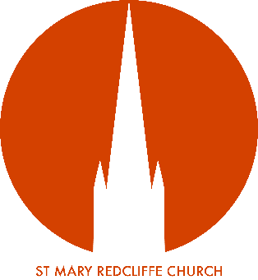
Volunteer Role Description:
Steward
Role Purpose:
St Mary Redcliffe Church is an open and inclusive space which welcomes thousands of visitors and tourists through its doors every year. These people will come from many diverse backgrounds and for some, it may even be their first time in a church building. Often as the first line of connection and welcome to the church, our team of Stewards are an essential part of the visitor experience as people arrive through the doors.

With that in mind, the main purpose of the role of Steward is to provide a warm welcome and any relevant assistance, including basic information on the history of the church to all visitors and tourists coming to the church during regular opening hours.

Volunteer Supervision:
Managed By: | Marion Durbur  Head Steward | Additional Support: | Chris Whitwell  Volunteer Coordinator
Location of Role: | St Mary Redcliffe Church Building | Expected Time Commitment: | Varied
Key Tasks & Responsibilities:
- To give a warm welcome and be present to visitors and tourists coming into the church
- To represent St Mary Redcliffe in a positive manner
- To wear a name badge for identification purposes (spare Steward badges are available under the desk)
- To use the clicker to count visitors and to record numbers in the diary
- Where possible, to answer visitors questions and if necessary, use the Stewards Handbook to help
- To be able to answer basic questions on the history of St Mary Redcliffe
- To recommend the use of the contactless card machine for donations as an alternative to using cash
- To enlist the help of the Verger(s) if there are any causes for concern
- To ensure that the environment is kept safe by following relevant health and safety procedures
- To ensure any safeguarding issues and/or concerns are reported to the St Mary Redcliffe Safeguarding Officer
- To attend mandatory training when required e.g. Safeguarding, health and safety etc

Desirable Experience & Skills:
- A friendly and welcoming manner, making people feel comfortable in what might be unfamiliar surroundings
- A reliable and committed member of the stewarding team
- An awareness of the possible needs of those coming into church e.g. information sheets in a visitors own language, relevant pamphlets etc
- A basic knowledge of safeguarding and how to protect vulnerable people from harm
- Enthusiastic about St Mary Redcliffe Church, with an interest in its history and current tourism offer and ready to share this with our visitors.
- Good communicator and confident in speaking to people (adults and children)
- No qualifications or experience necessary, but a desire to work with the public is a must.
- An enthusiasm for relevant subjects (Christianity, history, art) desirable.

Training/Induction Requirements:
- Basic safeguarding
- Health and safety
- Basic history of St Mary Redcliffe

Safeguarding:
All staff and volunteers are expected to demonstrate a commitment to safeguarding the welfare of all children and adults who may be vulnerable, who are involved with and/or visit St Mary Redcliffe. This will include adherence to policies and procedures, following good practice in relation to their own behaviour and conduct and undertaking any safeguarding duties commensurate with their specific role.

DBS Eligibility
Is this role eligible for a DBS check: ☐ Yes ☒ No
If yes specify the level of check required:
Standard: ☐ Enhanced ☐ Enhanced with Barred list ☐
Health & Safety:
At all times when carrying out any volunteering role for St Mary Redcliffe, you must take reasonable care for your own health & safety and that of any other person who may be affected by your acts or omissions. In addition, you must co-operate with the Organisation on health & safety and not interfere with, or misuse, anything provided for your health, safety or welfare.

