The Peer Partnership
Type 2 diabetes Peer Mentor Application
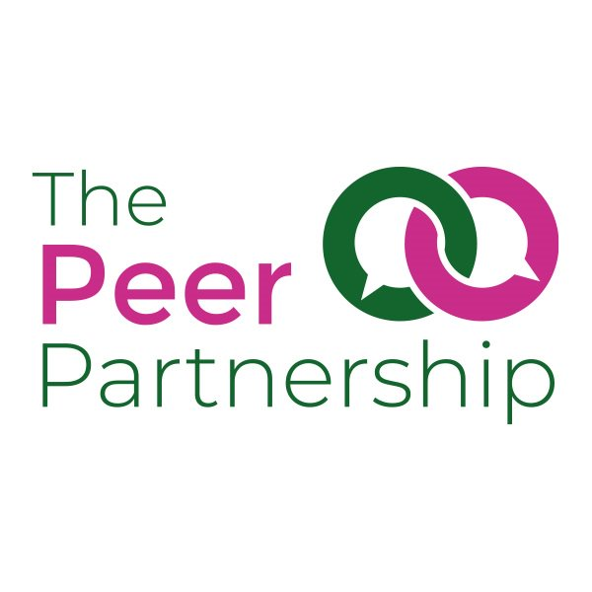
The Peer Partnership provides peer support to people living with type 2 diabetes.
Our volunteers are valued and respected for the time and effort they give towards maintaining and enhancing our services. As a volunteer in the Peer Support Service you will have the chance to use your existing skills and hopefully gain some new ones.

Becoming a Peer Support volunteer involves:
- Completing the enclosed application form, which includes a section on criminal convictions
- Providing Two references
- A short interview with the Peer Support Coordinator and a volunteer mentor
- Attending a 3 day training course
- A one and a half hour induction online with the Peer Support Coordinator, and includes an overview of the organisation, policies and procedures and further details on the mentoring process.

The training course runs over 3 sessions across 3 days and will be held at Easton Community Centre. It will cover topics such as: expectations as a Peer Partnership volunteer, basic diabetes medical information and good practice in managing diabetes, confidentiality and listening skills. The course is designed to make use of your own knowledge, skills and experience. It aims to prepare you for the tasks and any challenges you might encounter while you are volunteering.

Once you become a volunteer
Volunteers will receive reasonable out of pocket expenses including mileage allowance or bus fare for face to meetings including a refreshments allowance. There is ongoing support and opportunities for training to support you in your role.

IMPORTANT!
Please refer to these notes before completing the application form

1. Help with completing the form
If you need help in completing the form for any reason at all, please contact the Peer Partnership. This will not go against you when you apply.

2. What we look for in a volunteer
Please see the Peer Support Volunteer Job Description. Please use the job description to help you understand what will be looked for in your application form, as it is through this form that the selection for the interview will be made.

This list of qualities that Brigstowe looks for in a volunteer has been designed to help you understand what we need, and to help decisions to be made in line with equal opportunities. No formal qualifications are required, and training will be provided

All these requirements will be explored during the training course.

3. The application process

When you return your form, the Peer Support Coordinator will assess it. If your application meets our standards you will be invited to an interview. If we consider that you are suitable for the role you will be given a place on the volunteer training and sent details before the programme starts. Please note, being offered a place on the training does not guarantee you to be a mentor. The training programme will also be an opportunity to assess your suitability to be a mentor.

If you have any questions about the role or application process, please get in contact with:

Denise Swain
Diabetes Peer Support Coordinator

The Peer Partnership Easton Community Centre
Kilburn Street
Easton
Bristol
BS5 6AW

0117 9555 038
info@peerpartnership.org

Peer Support Volunteer Application
Thank you for your interest in volunteering with the Peer Partnership. This form is an opportunity for you to give us some information about yourself. It forms part of our volunteer selection process.
Please complete it as fully as you can, using the peer support volunteer job description and information above to help you. Do not hesitate to contact us if you need any assistance in filling out this form.

Personal Details:

Name: Click or tap here to enter text.
Address: Click or tap here to enter text.
Date of Birth: Click or tap to enter a date.
Tel: Click or tap here to enter text.
Email: Click or tap here to enter text.

Is it ok to leave you a voicemail? Yes ☐ No ☐

Is it ok to text you? Yes ☐ No ☐

- Why are you interested in becoming a volunteer with The Peer Partnership?

Click or tap here to enter text.

- What skills, qualities and experience (paid or unpaid) can you offer the role of peer mentor? (please refer to the peer support volunteer role description

Click or tap here to enter text.

- The Peer Partnership works with people from a wide variety of backgrounds in terms of sexuality, drug use, ethnicity, employment etc. How do you feel about working with people who may have very different life experiences from your own?

Click or tap here to enter text.

- Do you speak/write any languages other than English?

Click or tap here to enter text.

- Our mentors will be providing a minimum of 1 hour a week to mentor someone who is diagnosed with type 2 diabetes. What days and times of day do you feel you would be able to do this (please check any that apply)?

 | Monday | Tuesday | Wednesday | Thursday | Friday | Saturday | Sunday
09:00-17:00 | ☐ | ☐ | ☐ | ☐ | ☐ | ☐ | ☐
17:00-21:00 | ☐ | ☐ | ☐ | ☐ | ☐ | ☐ | ☐

Declaration and DBS checks

Do you have any convictions, cautions, reprimands, or final warnings that are not “protected” as defined by the Rehabilitation of Offenders Act 1974 (Exemptions) Order 1975 (as amended in 2013)?

This information is treated as confidential

Tick as appropriate Yes ☐ No ☐
Please use this space to give dates and information
Click or tap here to enter text.
Please note this role will involve working with vulnerable people and so we will carry out an enhanced DBS (Disclosure and Barring Service, formerly Criminal Record Bureau check) which will show up all convictions, including spent convictions.

Having a criminal record will not necessarily prevent you from volunteering at The Peer Partnership. We may need to discuss with you any convictions that do appear, but this will be done in a sensitive and constructive manner. If you would like to discuss this before completing the form, please contact us on 01179555038.

References

Please give the names and addresses of two people who can comment on your suitability for volunteering with us. References will be contacted before the interview due to time restrictions.

Please note the references cannot be a partner or family member. They could be a friend, volunteer manager, trainer, tutor, or your work manager. consultant etc.

Please also note the references need to know your diabetes status – this is due to when we contact them we will be mentioning Brigstowe and that it is a Peer Support role.

Name: Click or tap here to enter text.
Address: Click or tap here to enter text.

Tel: Click or tap here to enter text.
Email: Click or tap here to enter text.
How do you know this person: Click or tap here to enter text.
Name: Click or tap here to enter text.
Address: Click or tap here to enter text.
Tel: Click or tap here to enter text.
Email: Click or tap here to enter text.
How do you know this person: Click or tap here to enter text.
Your contact details will be held on computer and this application form will be securely filed. All personal details held are secure and strictly confidential to the Peer Partnership. We will use the information for contacting you and for monitoring our volunteering base.
Please sign below to give your consent to us keeping this information on our records

Interview

Our preference is to offer face to face interviews. Interviews will be around 45 minutes. Please answer the following questions to help us provide the most appropriate interview situation for you:

Do you have any specific accessibility needs to attend, for example wheelchair access:

Click or tap here to enter text.

Signature

Applicants signature: Please enter email if filling in electronically

Date: Click or tap to enter a date.

Please return to:
info@peerpartnership.org
Brigstowe, Easton Community Centre, Kilburn Street, Easton, Bristol, BS5 6AW
Equal Opportunities

The Peer Partnership aims to ensure that all applicants are treated fairly and are not discriminated against, either directly or indirectly, on grounds of ethnic origin, gender, disability, sexuality, age or religion. We will try to gather information from applicants to check that we are not discriminatory in who we shortlist and select. The information provided will only be used for statistical purposes.

Please return this form with your application. The form will not be looked at until after the recruitment process is finished and will have no bearing on your application for employment. If you prefer, please send separately to your application form.

How did you find out about this post?

☐The Peer Partnership website
☐Diabetes and Nutrition Service
☐Bristol Diabetes Support Network
☐GP (please state): Click or tap here to enter text.
☐Word of Mouth
☐Social media (please state): Click or tap here to enter text.
☐Other (please state): Click or tap here to enter text.

Demographic Information
Gender
Female  ☐ | Male  ☐ |  | Non-Binary  ☐ |  |  |  |  | Prefer not to say ☐ |  |  |  | Is this the gender you were assigned at birth? Y☐/ N☐/Prefer Not to say☐
Ethnicity
Asian | Bangladeshi  ☐ |  |  | Indian  ☐ |  |  |  |  |  | Pakistani  ☐ |  |  |  |  |  | Any other Asian background ☐
Black | African ☐  (pls specify which country) ………………..................... |  |  |  |  |  |  | Black/Black British  ☐ |  |  |  |  |  |  | Caribbean  ☐
Chinese | Chinese  ☐ |  |  |  |  |  |  | Latin American |  |  |  |  |  |  | Latin American  ☐
White | British  ☐ |  |  | Irish  ☐ |  |  |  |  |  |  | Gypsy/traveller  ☐ |  |  |  |  |  |  |  | Any other  ☐
Mixed ethnic background | Asian & White  ☐ |  |  | Black African & White  ☐ |  |  |  |  |  |  | Black Caribbean & white  ☐ |  |  |  |  |  |  |  | Mixed other  ☐
Other | Any other ethnic background  ☐ |  |  |  |  |  |  | Prefer not to say |  |  |  |  |  |  | Prefer not to say  ☐
Sexual Orientation
Asexual/non sexual  ☐ |  | Bisexual  ☐ |  |  |  |  | Gay/lesbian  ☐ |  |  |  |  |  | Heterosexual  ☐ |  |  |  | Prefer not to say  ☐
Religion
Buddhist  ☐ | Christian  ☐ |  |  |  | Hindu  ☐ |  |  |  | Jewish  ☐ |  |  |  |  | Muslim  ☐ |  |  |  | Sikh  ☐
Other religion  ☐ |  |  |  |  | No religion  ☐ |  |  |  |  |  |  |  |  | Prefer not to say  ☐
Disability
Disabled ☐ |  |  |  |  |  | Non-disabled ☐ |  |  |  |  |  |  |  |  | Prefer not to say ☐

