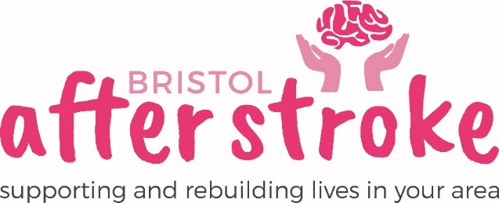

Trustee

Role Title | Trustee
Responsible to: | Chairperson of the Trustees
Time Commitment: | Trustees will be asked to commit to about 1 days’ volunteering a month.  Time commitment will include attending 6 board meetings a year (lasting 1.5 hours – 2 hours each) and Trustees may also be asked to be on a subcommittee.  Trustees are expected to serve a 3-year period.
Location: | Bristol / South Gloucestershire (Meetings are either held in person at our Bristol after Stroke office or via Zoom.)
Why we need your help:
Bristol After Stroke is a vibrant independent charity helping people in Bristol, South Gloucestershire and surrounding areas to rebuild their lives after stroke. We provide information, practical support, friendship and counselling in the months and years following a stroke.
We are looking to appoint a new Trustee with a variety of skills, perspectives, and experiences, to join our Board to help us shape our charity’s future. This is an exciting time to be involved in the charity. We recently agreed a significant new contract which will see our team and reach into the stroke community grow so we are looking for someone who is engaged with the cause, energetic and passionate. You will be able to think strategically and practically about the challenges and opportunities the organisation may face, whilst also providing leadership, scrutiny and support.
We are particularly interested to hear from candidates from under-represented groups which would include Asian, Black, and other ethnic minority communities. This is particularly relevant because these groups over-index in Stroke occurrence. We also look for more participation from disabled people and young people.

Role Summary:

- Ensuring that the organisation pursues its stated purposes, as defined in its governing document, by developing and agreeing a long-term strategy.
- Ensuring that the organisation complies with its governing document, charity law, company law and any other relevant legislation or regulations.
- Ensuring that the organisation applies its resources exclusively in pursuance of its charitable objects for the benefit of the public.
- Ensuring that the organisation defines its goals and evaluates performance against agreed targets.
- Safeguarding the good name and values of the organisation.
- Ensuring the effective and efficient administration of the organisation, including having appropriate policies and procedures in place.
- Ensuring the financial stability of the organisation.
- Protecting and managing the property of the charity and ensuring the proper investment of the charity’s funds.
- Following proper and formal arrangements for the appointment, supervision, support, appraisal, and remuneration of the chief executive.
In addition to the above statutory duties, each trustee should use any specific skills, knowledge or experience they have to help the board of trustees reach sound decisions. This may involve scrutinising board papers, leading discussions, focusing on key issues, providing advice and guidance on new initiatives, or other issues in which the trustee has special expertise.

Skills /Experience and Personal Attributes:
- Previous Board experience is not necessary, but an understanding of, or a willingness to train in, the principles of good governance in the charity sector is essential.

What we can offer you:
- An induction in the role.
- You will be supported in your role by the Chief Executive and The Chairperson of the Trustees.
- We will pay out of pocket expenses as agreed.
What we ask of you:
- To obtain 2 references from people who are not related to you.
- To complete an Enhanced DBS check
- To keep to all the charity’s policies, values and guidelines.
- To complete an induction and any necessary training for the role, including attending Safeguarding and Aphasia Training.

