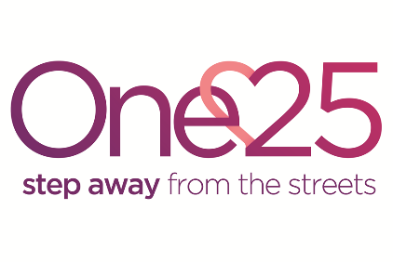
Volunteer Van Driver: Volunteer Application Form
Thank you for your interest in volunteering for One25. If you need assistance completing this form please telephone 0117 909 8832 or email iwanttovolunteer@one25.org.uk
Please provide your contact details:
Full Name
Preferred name
Address
Postcode
Telephone
Email
Date of birth

Please note before completing this application: we are currently only accepting applications from volunteers who can commit to a minimum of 2 shifts a month for longer than a year.

Which nights would you be available to volunteer?
Please tick all that apply:
Mondays  8:45pm to 12:30am | Tuesdays  8:45pm to 12:30am | Wednesdays  8:45pm to 12:30am | Thursday  8:45pm to 12:30am | Friday  8:45pm to 1:30am | Saturday  8:45pm to 1:30am | Sunday 8:45pm to 12:30am

Your Age
To volunteer with our women you need to be 18 or over.
I am 18 or older: o Yes o No

To volunteer in this role you need have a valid driving license:
I hold a valid driving license: o Yes o No

DBS Checks
We ask all frontline volunteers to undergo a Disclosure and Barring Service (DBS) check. Having a criminal record will not necessarily prevent you from volunteering with One25.
Tick as appropriate. I have criminal convictions, spent or unspent: o Yes o No

Recent history of street sex work or addiction to drugs/alcohol
We welcome volunteers who have a background of street sex work and/or have recovered from addictions. However, for your safety and the safety of the women we support, we do not recruit frontline volunteers who have been involved in street sex work within the last two years or are in active addiction. For frontline volunteers who have a recent (last 2 years) history of addiction to drugs/alcohol/other substances, recruitment depends upon the outcome of a welfare assessment with our drug and alcohol recovery worker.

Please tick as appropriate.
I have been involved in street sex work in the last 2 years:
o Yes o No

I’ve had an addiction to drugs/alcohol/other substances:
o Yes o No

Please answer the following questions:
- Why do you want to volunteer for One25?

- How long (e.g. how many months or years) do you think you are likely to be able to volunteer at One25 for?

- How do you plan to balance volunteering and other commitments (such as work, family, studying and welfare)?

- What relevant skills do you have to bring as a volunteer?

- In relation to the role you are applying for, what do you want to learn from volunteering at One25?

Please provide details of referees we can contact to comment on your suitability for volunteering. These can be colleagues or friends but not family members.

Referee One | Referee Two
Name: | Name:
Address: | Address:
Email: | Email:
Telephone: | Telephone:
How do you know this person? | How do you know this person?

Declaration
I give permission for One25 Limited to retain any relevant data about me (including relevant sensitive data) that is received verbally or in writing or is kept in electronic form, on the understanding that it will only be used or disclosed in connection with the work of One25 Limited or at my specific written request: e.g. for a reference.
I confirm that all the information I have supplied in this application is complete and accurate.

________________________________________________ __________________
Signed Date
Please return this form by email to iwanttovolunteer@one25.org.uk

