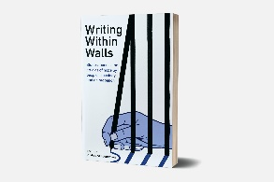
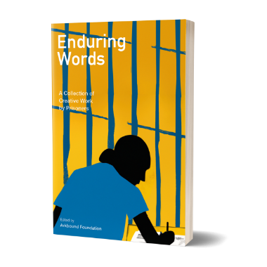
Arkbound Foundation’s “Writing Within Walls” mentoring programme

Task: Please read the short poem below and guess the background of the author
“SPRING”

Xanthic in colour, daffodils tower,
Over the polychrome Crocus,
Diminutive Chicks huddle together,
With their ebullient mother,
Whilst the warm spring breeze blows
Pied Cherry blossoms.

Lambs gambol amongst lush pastures
In the idyllic countryside.
Dauntless ravens rest cosily,
Aloft cottage rooftops.
Parents watching children frolic,
In meandering becks and streams.
Countryside aromas Waft, Wander and
Weave through ramblers’ sinuses.
Sentry like geese guard farm buildings and yards.
Charlie the sheepdog’s indominable
Spirit must not be denied.

Answer: This poem was sent to me by my mentee Julie, from HMP Styal, serving her 12th year of a life sentence…
Arkbound Foundation’s “Writing Within Walls” projects

Background: Arkbound got established as grassroots, lived experience, equality, diversity led social enterprise publisher in Bristol in 2015, then incorporated into Arkbound Foundation CIO charity in 2017, and as OSCR registered SCIO member in Scotland in 2019.

Our projects and books breath equality, diversity, environmental action and social inclusion in everything we do, plan and achieve. We believe in giving people a voice and empowering them through writing. Arkbound’s missions of social inclusion are written into our governing document, where supporting people with experience of custody and imprisonment is directly mentioned as an objective. We improve equality, diversity and social mobility by creating awareness, giving disadvantaged people a voice, getting their stories heard and published, for our civic society, authorities, institutions and those in power, able to activate needed improvements and changes.

While our society still has a long way to go in achieving decent equality standards related to protected characteristics, it fails to challenge other bias, outlined in a blog by our founder:
Modern Prejudice: Some forms of discrimination are decried, whilst others are deemed acceptable | Arkbound | Charity Book Publisher

Arkbound Foundation has provided support for prisoners, people affected by experiences of custody and past convictions since we started. We reached out and listened, provided writing workshops in prisons, launched encouraging writing competitions with prizes, published winning entries in our magazine Boundless first, then as collections: On the theme of hope: 'Writing Within Walls' by Arkbound Foundation | Arkbound | Charity Book Publisher and on resilience: Enduring Words: A Collection of Creative Work by Prisoners | Arkbound | Charity Book Publisher Our founder Stephen also published a book about his experience of custody: 'Just Time' by Stephen Jackley | Arkbound | Charity Book Publisher

Our Mentoring Programme

Here I can tell you what I do:
Arkbound Foundation provides free writing mentoring to prisoners: our WWW project coordinator matches up mentors with mentees. Our outreach provisions get mainly delivered online and through letters, since Covid measurements restricted in-person workshops. Prisoners have restricted online access, so our mentors correspond with them via postal letters send to their HMP, with their first name and prison ID numbers indicated in the address.

We are only a small charity but can pride ourselves for making our mentoring programme available to all potential UK beneficiaries while also networking and communicating well with likeminded organisations who let the people we try to reach and help know about us.

Julie and Val - our WWW mentoring agreement: I got introduced through our WWW coordinator to Julie and started exchanging letters with her before Christmas 2022. We both agreed and my application to volunteer as a mentor had been approved by Arkbound Foundation. Since then, I received her handwritten letters with her prison ID number in the top right corner, scanned by our WWW coordinator. My online replies get printed out and posted to Julie as letters.

My experience as WWW mentor: I’m impressed how talented Julie is writing poetry full of positivity, nature connections, kindness for animals, humans, our planet, expressing abundance and hope. As a child she liked spending time with her grandparents in a small country town surrounded by nature, providing her with a caring environment. It was something Julie otherwise didn’t have. Through her vivid life story revelations, I can visualize her dinner lady “Granma” waving with a big smile from the schoolyard, and Julie sitting on granddad’s shoulders, glancing over the wooden enclosure.

I’m saddened reading about what went wrong in Julie’s life: hints of recurrent abuse which made her feel worthless in her youth, and later influenced her making wrong decisions, bad choices, and going along with carrying out an abusive partner’s wishes.
Mentoring Julie confirmed insights I had gathered through my academic studies, stories of people I met, and my personal lived experience: we need to listen, giving everyone a voice to be able to make our society fairer, spot and avoid deprivation, disadvantage, and abuse. We need to facilitate, create and further an inclusive, person centred, community and society focused approach.
We need to heal wounds from the past, stop the circle of abuse, affecting victims as well as offenders from disadvantaged backgrounds. We need to understand what has gone wrong in many lives and provide a fair chance for people with convictions to leave their past behind them.

Last words: I hope my blog will inspire more people to become Arkbound Foundation WWW mentors, reach beneficiaries looking for the support and becoming mentees, inspire more likeminded organisations to network with us, also getting noticed and supported by funders.

Contact: Writing Within Walls (arkfound.org)
Arkbound Foundation,
Rogart Street Campus,
4 Rogart St. Bridgerton,
Glasgow G40 2AA

