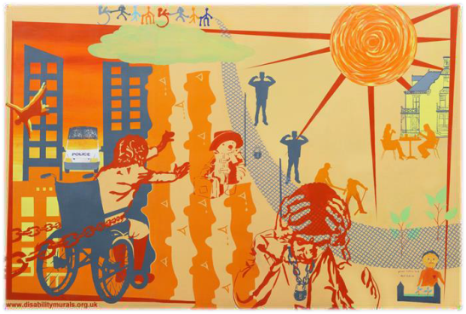
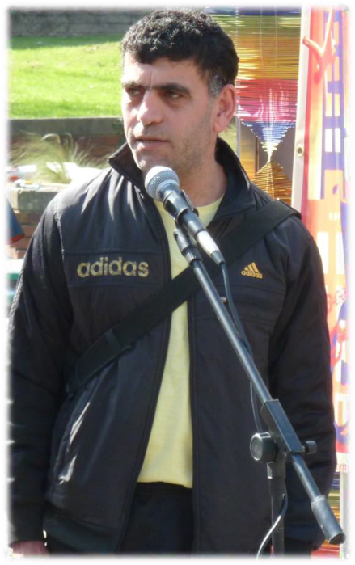

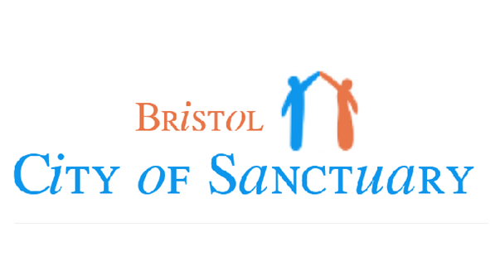


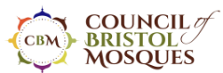

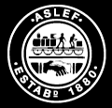
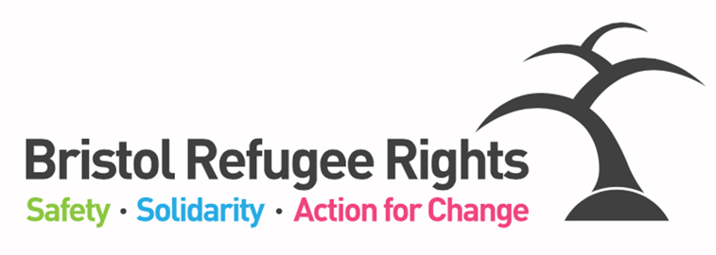
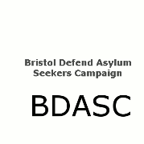
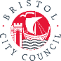


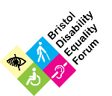


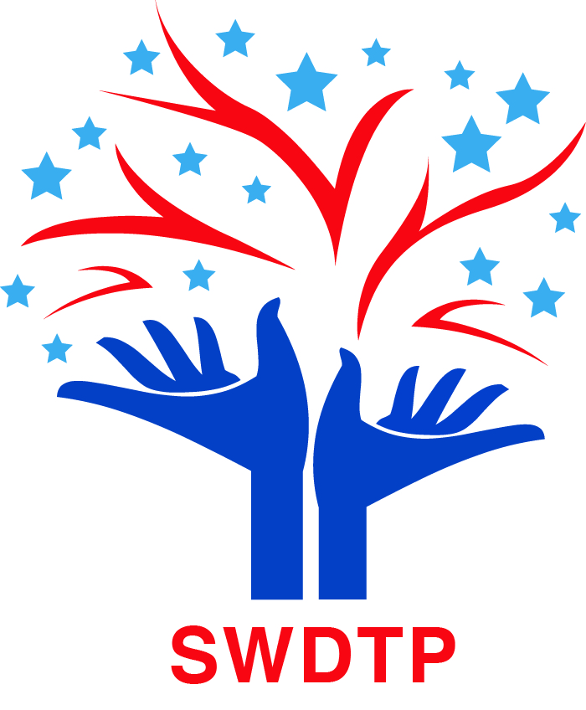
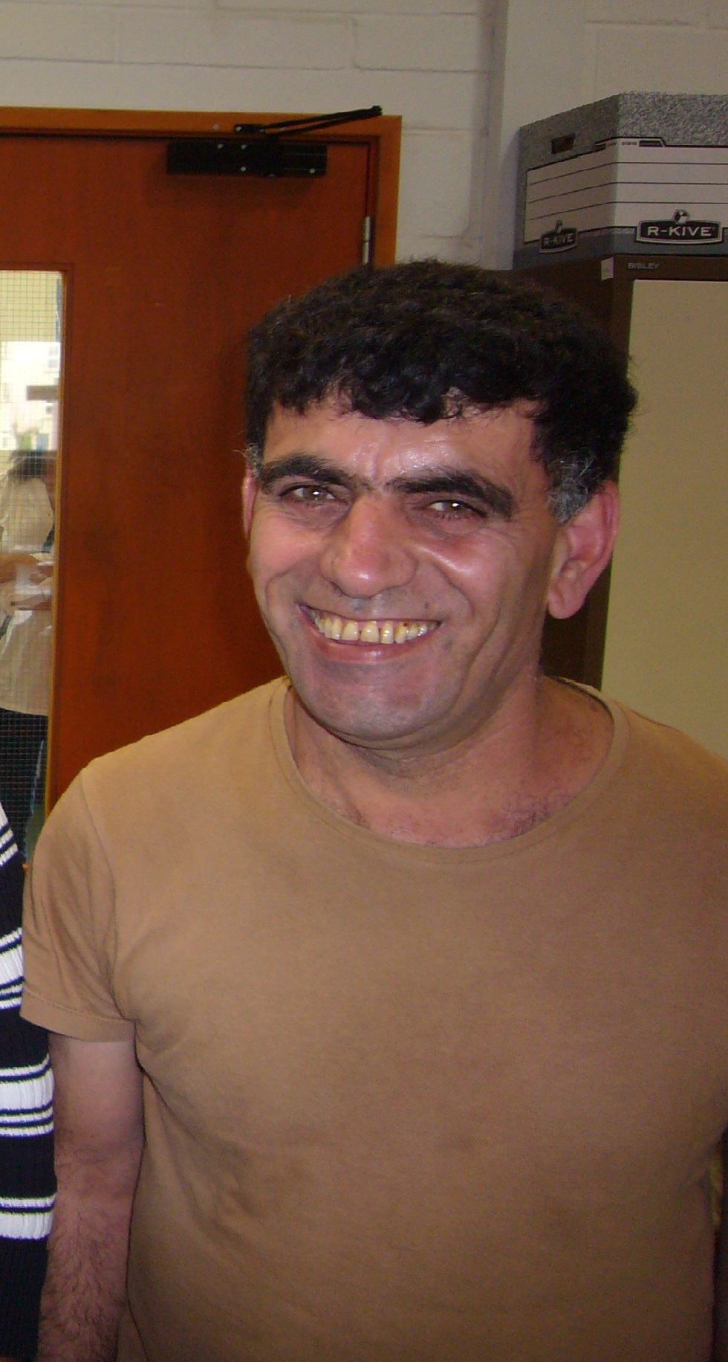
Kamil Ahmad and Bijan Ebrahimi, were both Disabled men who came to UK seeking sanctuary. They were both brutally murdered in Bristol.

Join us to honour them, learn from Disabled asylum seekers and build a broader movement for change.
2.30pm Bristol City Hall - Installing ‘Sorry’ Memorial
3.30pm Procession
4pm We the Curious (BS1 5DB). Talks, discussion food, music
www.facebook.com/disabilityandmigration

Refugees, citizens, disabled, non-disabled.
All for one, one for all. United we stand, divided we fall.

Honouring Kamil and Bijan:
Disability and Migration
June 29th 2018

