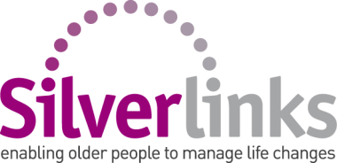

**1-2-1 Home Support Role Description**

WE Care & Repair aim to improve the quality, safety and suitability of more of the homes of older people, people on low incomes & disabled people. **To achieve this we need your help.** Volunteering for WE Care & Repair means you’ll help us reach more vulnerable people across the West of England, not only to improve their homes but also to increase individual’s resilience, confidence and sense of wellbeing. WE Care & Repair is a not-for-profit Home Improvements Agency with charitable status.

**Purpose of the role**

The aim of the 1-2-1 Home Support role is to provide emotional and mutual support to older people who may be particularly anxious about making decisions surrounding having work carried out in their home or moving. This role offers an excellent opportunity for individuals who would like to share their free time and skills to help people in their local community. Experience of having housing repairs, adaptations or moving is desirable but not essential to become a part of our volunteering team. We especially welcome applications from people aged 50+ and from BME communities for this role.

**What will you be doing and how often?**

* Visit clients who are anxious or worried about having work carried out in their home or are planning to move
* Help reduce their anxiety by offering empathy and emotional support
* If necessary, be present when WE Care & Repair staff or trusted contractors visit
* Empower clients to make decisions about their home and wellbeing by raising awareness of other services or organisations that may support the client; helping the client to access these if desired
* The length of a visit is generally two hours, the frequency of visits is to be mutually agreed between the volunteer and client and the period of support will be agreed by the Volunteer Coordinator
* The locations of the visits vary as we support clients across Bath & North East Somerset, Bristol, North Somerset or South Gloucestershire

**Personal qualities**

* A passion for supporting vulnerable people
* Have a warm, empathetic and non-judgemental communication style
* Ability to listen well
* Be patient and reliable
* Have confidence to support people in their homes on a 1-2-1 basis and work autonomously
* The ability to accurately and concisely document information
* Preferably have access to a car or a willingness to travel on public transport

**Other information**

DBS check: Due to the nature of the role you will need to have completed an enhanced Disclosure and Barring Service (DBS) check including a check of the DBS barred list before supporting a client.