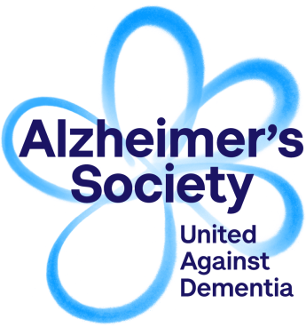
We collect this information to enable us to monitor the diversity of our volunteers and assess the effectiveness of our Equality, Diversity and Inclusion Policy. It will not be used in any other way and will be treated in confidence. If you would prefer not to disclose any of this information, please select the ‘prefer not to disclose’ option.
Volunteer Equal Opportunities Monitoring Form
Name:
Location of volunteering: |  |  |  |  |  |  |  | What is your date of birth?
Gender: | Male | Female
How would you describe your ethnic origin? (Please tick one option only)

Asian or Asian British
Bangladeshi |  |  | Indian |  |  | Pakistani |  |  |  | Chinese
Any other Asian background, please state:

Black or Black British
African |  |  | Caribbean
Any other black background, please state:

Mixed
White and Asian |  |  | White and Caribbean |  |  | Pakistani |  |  |  | Chinese
Any other mixed background, please state:

Other ethnic group
Arab |  |  | Any other ethnic background, please state:

White
British (English, Northern Irish, Scottish, Welsh) |  |  |  |  |  |  | Irish
Any other white background, please state:

Prefer not to say

What is your nationality?
Prefer not to say

What is your religion or belief? (Please tick one option only)
No religion | Christian | Buddhist | Hindu
Jewish | Muslim | Sikh | Prefer not to say
Other, please state:

What is your sexual orientation? (Please tick one option only)
Bisexual | Gay man | Gay woman/lesbian | Heterosexual/straight
Other, please state: |  |  | Prefer not to say

Do you consider yourself to have a disability?
Yes | No | Prefer not to say

Are you affected by dementia in any of the following ways?
I have dementia | Yes | No | Prefer not to say
I am concerned about my memory | Yes | No | Prefer not to say
I am a carer | Yes | No | Prefer not to say
I am a former carer | Yes | No | Prefer not to say

