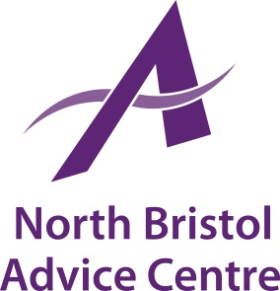

North Bristol Advice Centre is an independent charity which has been providing free and independent advice and support in North Bristol and South Gloucestershire for over 30 years. We currently have the following vacancy:

Job Title: Advice Triage Worker

Grade & Salary: £18,000 pro rata (+ 4% employer contribution pension)

Salary: 28 hours per week. Occasional evening/weekend work may
be required.

Place of Work: NBAC Office, Gainsborough Square Lockleaze, Bristol, plus
outreach locations in Bristol and the surrounding areas.

Main Purpose of Job

This is a key role within the organisation and the successful applicant will work alongside other staff members to effectively delivery NBAC’s Advice Service. You will be expected to interview clients, diagnose their issues and advise and/or signpost the client to the completion of their issue and related issues.

Deadline for Applications: Friday 12th July 2019
Interviews: 17th July 2019

Contact us for an application pack:
admin@northbristoladvice.org.uk or 0117 951 5751
Download from our website www.northbristoladvice.org.uk/get-involved/jobs

